Style Guidelines for Final Year Project ReportsDrive Net

Final Year Project – Mid Report

Session 2020-2024

A 4th Year Student

A project submitted in partial fulfilment of the

COMSATS University Degree

of

BSc. (Hons.)BS in Computer Science / Software Engineering (CUI)



Department of Computer Science

COMSATS University Islamabad, Lahore Campus

13 December 2023

**Project Detail**

|  |  |  |  |  |  |
| --- | --- | --- | --- | --- | --- |
| Type (Nature of project) | | | [ ] **D**evelopment [ ] **R**esearch [ ] **R**&**D** | | |
| Area of specialization | | |  | | |
| **Project Group Members** | | | | | |
| Sr.# | Reg. # | Student Name | | Email ID | *Signature |
| (i) | Group Leader  FA20-BSE-051 | Muhammad Zohaib | | [FA20-BSE-051@cuilahore.edu.pk](mailto:FA20-BSE-051@cuilahore.edu.pk) |  |
| (ii) | FA20-BSE-064 | Hafiz Kunwar M. Ahmad | | [FA20-BSE-064@cuilahore.edu.pk](mailto:FA20-BSE-064@cuilahore.edu.pk) |  |
| (iii) | FA20-BSE-071 | Muhammad Mehroz | | [FA20-BSE-071@cuilahore.edu.pk](mailto:FA20-BSE-071@cuilahore.edu.pk) |  |

*The candidates confirm that the work submitted is their own and appropriate credit has been given where reference has been made to work of others

**Plagiarism Free Certificate**

This is to certify that, I am ____Muhammad Zohaib____ S/D/o ___Muhammad Zahid___, group leader of FYP under registration no CIIT/FA20-BSE-051/LHR at Computer Science Department, COMSATS University Islamabad, Lahore Campus. I declare that my FYP proposal is checked by my supervisor and the similarity index is ________% that is less than 20%, an acceptable limit by HEC. Report is attached herewith as Appendix A.

Date: ____________ Name of Group Leader: __Muhammad Zohaib___ Signature: _____________

Name of Supervisor: _____________________ Co-Supervisor (if any):____________________

Designation: _____________________ Designation: _____________________

Signature: _____________________ Signature: _____________________

**Abstract**

In the digital age, vehicle selling is evolving with technology and changing consumer preferences. The 'DriveNet' project introduces a unique website to address the challenges faced by vehicle sellers and buyers. ‘DriveNet’ project aims to create a vehicle trading site, that allows the sellers to list their vehicles for sale and allow the buyers to view them, and contact the respective sellers in the regard of buying it. ‘DriveNet’ employs ML to accurately estimate vehicle price to offer best values for both seller and buyer. It also targeted to develop a vibrant community for car enthusiasts who share common passion for cars or motorcycles. Key objectives include an 80% accuracy rate for price predictions, user base growth, 75% user satisfaction, and a fair feedback system. DriveNet focuses exclusively on vehicles, offering an intuitive interface, ML price predictions, and a built-in community for user engagement and guidance. The project aims to simplify the vehicle selling process, enrich user experience, and connect enthusiasts. Methodology includes requirements gathering, design, technology stack selection, development, machine learning, community integration, and rigorous user testing. The architecture of the system is client-server with object-oriented architecture style.

Table of Contents

1 Chapter 1 - Introduction 13

1.1 Introduction 14

1.2 Objectives 15

1.3 Problem Statement 16

1.4 Assumptions and Constraints 16

1.5 Project Scope 16

1.6 Machine Learning Models 17

1.6.1 Random Forest Model 17

1.6.2 Support Vector Machines 17

1.6.3 K – Nearest Neighbors (KNN) 17

1.6.4 Recurrent Neural Network (RNN) 17

2 Chapter 2 – Requirement Analysis 19

2.1 Literature review 19

2.2 Stake Holder List 20

2.3 Requirement Elicitation 20

2.3.1 Functional Requirements 20

2.3.2 Non-Functional Requirements 26

2.3.3 Requirement Traceability Matrix 28

2.4 Use Case Design 30

2.4.1 User Registration 30

2.4.2 User Log In 30

2.4.3 Reset Password 31

2.4.4 Admin Management 31

2.4.5 Create Listing Ad 32

2.4.6 Edit Listing 33

2.4.7 Browse Listings 33

2.4.8 Search and Filtering 34

2.4.9 Contact and Messaging 34

2.4.10 Issue Reporting 35

2.4.11 Interact Community 36

2.5 Software Development Life cycle and Justification 37

2.5.1 Justification for Agile Scrum Adoption in DriveNet: 37

2.5.2 Summary: 38

3 Chapter 3 - System Design 39

3.1 Work Breakdown Structure Diagram 40

3.2 Activity Diagrams 41

3.2.1 User Registration 41

3.2.2 User Login 42

3.2.3 Listing Ad Activity 43

3.2.4 Edit Vehicle Listing Activity 44

3.2.5 Price Prediction Activity 45

3.2.6 Vehicle Browsing and Buying 46

3.2.7 Search and filtering 48

3.2.8 Contact and Messaging 49

3.2.9 Saving and Comparison 50

3.2.10 Admin: Issue Reporting Activity 51

3.2.11 Admin: Event Handling Activity 52

3.2.12 User: Issue Reporting 53

3.2.13 Community Interaction Module 54

3.2.14 Analytics 56

3.3 Sequence Diagram 57

3.3.1 Registration Sequence 57

3.3.2 Login Sequence 58

3.3.3 Create Vehicle Listing Sequence 59

3.3.4 Edit Vehicle Listing 60

3.3.5 Vehicle browsing and buying 61

3.3.6 Price Prediction Sequence 62

3.3.7 Chatting Sequence 63

3.3.8 Search and Filtering Sequence 64

3.3.9 Save and Comparing Sequence 65

3.3.10 Report Issue 66

3.3.11 Interact with community Sequence 67

3.3.12 View Analytics 68

3.4 Collaboration Diagrams 69

3.4.1 Registration Collaboration 69

3.4.2 Login Collaboration 70

3.4.3 Create Vehicle Listing Collaboration 71

3.4.4 Edit Vehicle Listing Collaboration 72

3.4.5 Price Prediction Collaboration 73

3.4.6 Browsing and Buying Collaboration 73

3.4.7 Chat and Messaging Collaboration 74

3.4.8 Search and Filtering Collaboration 74

3.4.9 Save and Comparing Collaboration 75

3.4.10 Issue Reporting Collaboration 75

3.4.11 Community Interaction Collaboration 76

3.4.12 Generate Report Collaboration 76

3.5 Class Diagram 77

3.6 Architecture Diagram 79

3.7 Database Diagram 80

4 Chapter 4 - System Testing 81

4.1 System Testing 82

4.2 Test Cases 82

4.3 Unit Testing 83

4.3.1 TC-01 User Registration 83

4.3.2 TC-02 User Login 84

4.3.3 TC-03 Forgot Password 84

4.3.4 TC-04 User Profile Edit 85

4.3.5 TC-05 Test User Management 86

4.3.6 TC-06 Test Vehicle listing 87

4.3.7 TC-06.1 Test Editing Vehicle listing 88

4.3.8 TC-07 Test Vehicle browsing and buying 88

4.3.9 TC-08 Test Search and filtering 89

4.3.10 TC-09 Test Contact and Messaging 90

4.3.11 TC-10 Test Saving and comparison 91

4.3.12 TC-11 Test Price prediction 92

4.3.13 TC-12 Test Issue reporting 92

4.3.14 TC-13 Test Community interaction and help 93

4.3.15 TC-14 Test Analytics 94

4.3.16 TC-NF-01 Test Performance 95

4.3.17 TC-NF-02 Test Reliability 96

4.3.18 TC-NF-03 Test Scalability 97

4.3.19 TC-NF-04 Test Availability 98

4.3.20 TC-NF-05 Test Security 98

4.3.21 TC-NF-06 Test Maintainability 99

4.3.22 TC-NF-07 Test Portability 100

4.3.23 TC-NF-08 Test Usability 101

4.3.24 TC-NF-09 Test Interoperability 101

4.3.25 TC-NF-10 Test Compliance 102

5 Chapter 5 – Conclusion 104

5.1 Project Summary 105

5.2 Problems Faced and Lessons Learned 105

5.3 Future Work 106

6 References 107

7 Appendix A 109

**List of Tables**

**List of Tables**

Table 1FR01 User Registration 21

Table 2 FR02 User Login 21

Table 3 FR03 User Profile 21

Table 4 FR04 User Management/Admin Panel 22

Table 5 FR05 List Vehicle for Sale 23

Table 6 FR06 Vehicle Browsing and Buying 23

Table 7 FR07 Search and Filtering 24

Table 8 FR08 Contact and Messaging 24

Table 9 FR09 Saving and Comparison 24

Table 10 FR10 Price Prediction 25

Table 11 FR11 Issue Reporting 25

Table 12 FR12 Community Interaction and Help 26

Table 13 FR13 Analytics 26

Table 14 NFR01- Performance 26

Table 15 NFR02 Reliability 27

Table 16 NFR02 Scalability 27

Table 17 NFR04 Availability 27

Table 18 NFR05 Security 27

Table 19 NFR06 Maintainability 27

Table 20 NFR07 Portability 27

Table 21 NFR08 Usability 28

Table 22 NFR09 Compliance 28

Table 23 NFR10 Interoperability 28

Table 24 Requirement Traceability Matrix 29

Table 25 TC-01 User Registration 84

Table 26 TC-02 User Login 84

Table 27 TC-03 Forgot Password 85

Table 28 TC-03 User Profile Edit 86

Table 29 TC-03 Test User Management 87

Table 30 TC-06 Test Vehicle Listing 88

Table 31 TC-06.1 Test Vehicle Listing 88

Table 32 TC-07 Test Vehicle Browsing and Buying 89

Table 33 TC-08 Test Search and Filtering 90

Table 34 TC-09 Test Contact and Messaging 91

Table 35 TC-03 Test Saving and comparison 91

Table 36 TC-11 Test Price Prediction 92

Table 37 TC-12 Test Issue reporting 93

Table 38 TC-13 Community interaction and help 94

Table 39 TC-14 Test Analytics 95

Table 40 TC-NF-01 Test Performance 96

Table 41 TC-NF-02 Test Reliability 96

Table 42 TC-NF-03 Test Scalability 97

Table 43 TC-NF-01 Test Availability 98

Table 44 TC-NF-05 Test Security 99

Table 45 TC-NF-05 Test Maintainability 100

Table 46 TC-NF-01 Test Portability 100

Table 47 TC-NF-08 Test Usability 101

Table 48 TC-NF-09 Test Interoperability 102

Table 49 TC-NF-10 Test Compliance 103

**List of Figures**

Activity Diagram 1 User Registration 39

Activity Diagram 2 User Login 40

Activity Diagram 3 Listing Vehicle 41

Activity Diagram 4 Edit Vehicle Listing 42

Activity Diagram 5 Price Prediction 43

Activity Diagram 6 Vehicle Browsing and Buying 44

Activity Diagram 7 Search and Filtering 45

Activity Diagram 8 Contract and Messaging 46

Activity Diagram 9 Saving and Comparison 47

Activity Diagram 10 Reporting Issue 48

Activity Diagram 11 Event Handling 49

Activity Diagram 12 Issue Reporting 50

Activity Diagram 13 Community Interaction 51

Activity Diagram 14 View Analytics 52

Collaboration Diagram 1 User Registration 64

Collaboration Diagram 2 Login User 65

Collaboration Diagram 3 Vehicle Listing 66

Collaboration Diagram 4 Edit Vehicle Listing 67

Collaboration Diagram 5 Price Prediction 67

Collaboration Diagram 6 Browsing and Buying 68

Collaboration Diagram 7 Chat and Messaging 68

Collaboration Diagram 8 Search and Filtering 69

Collaboration Diagram 9 Saving and Comparing 69

Collaboration Diagram 10 Issue Reporting 70

Collaboration Diagram 11 Community Interaction 70

Collaboration Diagram 12 Generate Report 71

Figure 1 WBS Diagram 38

Figure 2 Class Diagram 72

Figure 3 Architecture Diagram 73

Figure 4 Database Diagram 74

Sequence Diagram 1 Registration 53

Sequence Diagram 2 Login 54

Sequence Diagram 3 Create Vehicle Listing 55

Sequence Diagram 4 Edit Vehicle Listing 56

Sequence Diagram 5 Vehicle buying 57

Sequence Diagram 6 chatting sequence 58

Sequence Diagram 7 Search and filter 59

Sequence Diagram 8 Save and compare 60

Sequence Diagram 9 Report Issue 61

Sequence Diagram 10 Interact with community 62

Sequence Diagram 11 View Analytics 63

Use Case Diagram 1 User Registration 28

Use Case Diagram 2 User Login 28

Use Case Diagram 3 Reset Password 29

Use Case Diagram 4 Admin Management 30

Use Case Diagram 5 Create Listing Ad 30

Use Case Diagram 6 Edit Listing 31

Use Case Diagram 7 Browse Listing 31

Use Case Diagram 8 Search and Filtering 32

Use Case Diagram 9 Contact and Messaging 32

Use Case Diagram 10 Reporting Issue 33

Use Case Diagram 11 Community Interaction 34

# Chapter 1 - Introduction

## Introduction

In the fast-paced landscape of today's digital age, the automotive industry is witnessing a transformative evolution having the implementation of cutting-edge technology and the ever-shifting requirements of consumer preferences. When individuals decide to buy or sell a car, they often find themselves confused with a bunch of questions, ranging from the choice of the best platform for their transaction to the quest for an accurate valuation of their vehicle. Questions such as "What's the right price?" and "How can I connect with fellow car enthusiasts?" create a complex web of challenges that can lead to seller's remorse or buyer's regret. It is in response to these challenges that we proudly introduce "DriveNet," a modern project set to redefine the automotive experience.

DriveNet is focused at creating a website for vehicle trading, price prediction, and community interaction. Sellers are able to list their cars or motorcycles for sale, while buyers can view the listed vehicles and then can contact their sellers for further discussions. DriveNet, offers a built-in live chatting module to create contact between sellers and buyers without showing their personal details. It also allows view seller details if seller opt in, and seller is notified about people who viewed their details, it let seller know who to expect further calling and contacting. In this way, DriveNet offers a safe and secure, vehicle trading platform.

At its core, DriveNet is not merely a website; it is a comprehensive platform designed to address the concerns of both sellers and buyers in the automotive market. One of its pivotal features is the integration Machine Learning technology to predict the right price worth of their vehicle for a successful trade. Machine Learning modal will be trained using a sophisticated linear regression algorithm, to accurately estimate the fair market value of a vehicle. This technological backbone ensures that sellers are not left in the dark, armed with the knowledge and confidence needed to make well-informed decisions. The linear regression model employed by DriveNet is a robust tool, capable of analysing a multitude of factors to provide a precise valuation, minimizing the uncertainties that often accompany pricing in the automotive market.

However, DriveNet crosses the conventional boundaries of transactional platforms. It is not merely a space for buying and selling vehicles; it is a community that aims to bring together individuals who share a common passion for cars and bikes. The platform acts as a virtual hub for vehicle enthusiasts, offering them the opportunity to connect with like-minded individuals, share their experiences, and engage in vibrant discussions. Users can make posts in the community, view others posts, their project cars and motorcycles, comment on them or find best modification suggestions for their vehicles.

As part of the DriveNet community, users can expect not only selling of their vehicles through the listing ads but also a wealth of information about upcoming automotive events in their local communities. This integration of real-time event information further enhances the user experience, making DriveNet a holistic platform that caters to the diverse needs and interests of car enthusiasts. Whether it's a local car show, a community meet-up, or a significant automotive event, DriveNet keeps its users in the loop, ensuring that they remain connected with the dynamic world of automobiles.

In conclusion, DriveNet emerges as a game-changer for vehicle traders and car enthusiasts alike. This innovative platform, powered by cutting-edge Machine Learning technology, not only simplifies the process of buying and selling cars but also empowers users with accurate valuations through its robust linear regression (Machine Learning algorithm). Beyond transactions, DriveNet fosters a sense of community, providing a virtual space for like-minded individuals to connect, share experiences, and engage in vibrant discussions about their shared passion for cars and bikes. Moreover, its commitment to keeping users informed about local automotive events adds an exciting dimension, making DriveNet a comprehensive hub for both practical trading and the celebration of the dynamic world of automobiles.

## Objectives

The goal of the project is to provide a platform for selling and purchasing of used/preowned vehicles, including guidance from both ML (price prediction) and built-in vehicle community.

* Simplify vehicle selling by connecting sellers and buyers by creating a vehicle trading site
* Develop accurate vehicle price prediction tool with minimum optimal accuracy of 80%.
* Implementing feedback and problem reporting system to ensure reliability of the system.
* Create a community for vehicle enthusiasts to showcase projects, chat, and seek advice.
* Improve the vehicle selling and buying experience for profitability and enjoyment.
* Connect people interested in cars and motorcycles
* Create a fair and safe vehicle trading experience
* Introduce a website to know vehicle’s worth (price) without the need of inspection and its costly fees

## Problem Statement

Today's digital age, the re-selling of old vehicles through online marketplaces has become increasingly popular. However, both sellers and buyers face several challenges in this process. One of the most significant challenges is determining the optimal selling price for used items. Sellers often struggle to set a competitive price that reflects the item's true value, while buyers aim to make informed purchasing decisions based on fair market prices. While the vehicle owners often seek opportunities to connect with like-minded individuals who share a passion for automobiles. And buyers are looking for people for guidance about the right vehicle and its price of course. Many platforms offer car inspection [1] [2] to let buyers know However, finding relevant events and establishing connections within the automotive community can be challenging.

## Assumptions and Constraints

In envisioning the "DriveNet" project, several key assumptions lay the foundation for its success. It is assumed that a comprehensive and accurate dataset, encompassing diverse vehicle models and market dynamics, will be accessible for effective implementation. The engagement of users is presumed, anticipating active participation in the platform's features, including car selling, buying and getting predicted price. Additionally, the integration of advanced technologies, such as machine learning algorithms for precise car valuations, is expected to yield reliable results. It is also assumed that car enthusiasts will contribute to extend our community page by writing blogs, posts for the help and knowledge of the users.

One of the primary challenges faced by the "DriveNet" project lies in the inability to find an optimal dataset. The constraint arises from the difficulty in sourcing a comprehensive and accurate dataset that encompasses diverse vehicle models and market dynamics. This limitation may impact the accuracy and reliability of car valuations, potentially hindering the effectiveness of the platform. Another significant constraint revolves around the model's performance, which did not meet the anticipated standards. The project encountered challenges as the machine learning algorithms, responsible for car valuations, failed to yield the expected results. This limitation necessitates a revaluation and potentially an adjustment of the model to enhance its accuracy and predictive capabilities.

## Project Scope

The scope of the "DriveNet" project encompasses the development of a web-based platform for vehicle trading, which includes:

* **Price Prediction Module:** Developing a machine learning/deep learning-based module for vehicle price prediction for use convenience.
* **Vehicle Management Module:** For creating, editing, removing and sharing of vehicle advertisement.
* **Vehicle Viewer Module:** A module for viewing the on-sale vehicles and its details.
* **Chat Module:** A communication system to contact vehicle’s seller or vehicle enthusiasts in the community of website.
* **Vehicle Community Module:** A built-in community for vehicle enthusiasts for making friendships with each other to seek guidance and help from specialists. And for posts and events listings related to vehicles and automotive enthusiasts
* **UI Module:** User-friendly interfaces for both sellers and buyers.
* **Problem Reporting Module:** Feedback and reporting mechanisms for fair pricing.
* **Admin Module:** A panel for admin for handling reported issues, user management (blocking/unblocking), and posting the events in the community, and view website analytics.

## Machine Learning Models

### Random Forest Model

* Can handle complex relationships – many features of car contribute to its price so complex relationship exists
* Feature Importance – Features can be sorted by their importance e.g. car factory price may be at higher importance
* Handles missing data while maintaining accuracy – some sellers may not mention car condition

### Support Vector Machines

* Works with high dimensional data – car make, model, variant, year of manufacture, mileage, factory price, condition scale, and many more
* Encourages dimensionality reduction – reducing many features to less features
* Works best with non-Linear Relationship – after dimensionality reduction data can be plotted to see the linearity of data.

### K – Nearest Neighbors (KNN)

* No training phase – so quick way to test the system, and compare its results with other models
* Deals with outliers – as data is pre-processed and scaled usually between (0-1), so outliers don’t have must impact on accuracy

### Recurrent Neural Network (RNN)

* Handles temporal data – prices of cars tends to keep changing with time, so patterns among data may also change, which is handled by RNN
* History data – RNN keeps the past history of data which may be useful in predicting the price of old cars

# Chapter 2 – Requirement Analysis

## Literature review

In recent years, a surging interest in advancing automotive platforms has led to the emergence of innovative applications, reshaping the landscape of car buying and selling experiences. Noteworthy among these transformative services are:

**PakWheels** [3] has risen as a key player in the dynamic realm of online automotive marketplaces in Pakistan. Offering a comprehensive platform, PakWheels facilitates the seamless buying and selling of both new and used cars. Users benefit from an extensive range of features, including the ability to list their vehicles and connect effortlessly with potential buyers. Notably, PakWheels enhances the user experience by providing inspection services [1], ensuring both buyers and sellers receive the best value for their transactions.

**OLX Motors** [4]specifically, is a dedicated section within OLX that focuses on the buying and selling of vehicles. Users can post ads to sell their cars, motorcycles, and other vehicles, while those looking to purchase a vehicle can browse through the listings to find options that match their preferences. It offers the car inspection service to estimate the correct price of the vehicle by physically visiting the car owner/seller [2].

**Carwow**, a significant player in the automotive arena in the UK, specializes in revolutionizing the car buying process [5]. Renowned for its commitment to transparency and convenience, Carwow stands out by offering a unique approach. Users can effortlessly compare offers, connect with trusted dealers, find the best-suited cars, explore car leasing options, and even facilitate the selling of their cars. Carwow's multifaceted services cater to the diverse needs of car enthusiasts, simplifying every aspect of the car ownership journey.

**VAVACars** [6] presents itself as a hassle-free platform for users engaged in buying and selling cars. Going beyond the conventional, VAVACars offers additional services such as inspections to ensure the quality and reliability of listed vehicles. Moreover, users benefit from a value calculator for accurate pricing and have the option to seamlessly sell or trade in their cars. VAVACars stands out as a holistic solution, addressing various aspects of the car trading process to enhance user satisfaction.

**TrueCar** [7], a prominent figure in the realm of online automotive marketplaces in the United States, has solidified its position as a key player by offering a platform that redefines the car buying and selling experience. TrueCar's commitment to transparency and empowering users sets it apart, providing a comprehensive suite of services that cater to the diverse needs of individuals navigating the automotive marketplace.

Furthermore **DriveNet**, is poised to revolutionize the car trading experience. At the heart of DriveNet is a Price Prediction Module, a unique feature designed to empower users with accurate estimations for their vehicles. By leveraging advanced algorithms and market insights, DriveNet ensures that users receive a fair and competitive valuation for their cars. In doing so, DriveNet aims to redefine the dynamics of car valuation, contributing to a more informed and empowered automotive community.

## Stake Holder List

* Admin
* Seller
* Buyer

## Requirement Elicitation

### Functional Requirements

#### FR01 - User Registration

|  |  |
| --- | --- |
| FR01-01 | The system shall provide a user registration form with fields for essential information, including email, password, and optional profile details. |
| FR01-02 | The registration form shall implement validation checks to ensure that all required fields are filled, and the entered data meets specified criteria (e.g., valid email format, strong password). |
| FR01-03 | The system shall verify that the chosen username and email address are unique and not already associated with an existing account during the registration process. |
| FR01-04 | User passwords shall be securely encrypted before storage to protect user account information. |
| FR01-05 | The system shall verify the users through email to enhance trust with in the community |
| FR01-06 | The system shall allow registered users to switch the roles between seller and buyer. |

Table 1FR01 User Registration

#### FR02 - User Login

|  |  |
| --- | --- |
| FR02-01 | The system shall provide a secure login form with fields for username (or email) and password. |
| FR02-02 | The system shall provide different login portals for admin and general users (seller and buyer). |
| FR02-03 | The system shall authenticate users based on the entered credentials against the stored user data. |
| FR02-04 | The system shall allow users to reset and recover their passwords in case of forgotten credentials. |
| FR02-05 | The system shall handle the login sessions of the users and should logout the user after 30 days of non-activity. |
| FR02-06 | After a 20 unsuccessful login attempts, the system shall temporarily lock the user account to prevent unauthorized access. |
| FR02-07 | The login form shall include a "Remember Me" option, allowing users to stay logged in across sessions on the same device. |

Table 2 FR02 User Login

#### FR03 - User Profile

|  |  |
| --- | --- |
| FR03-01 | The system shall provide a profile page to allow sellers and buyers to view their current information. |
| FR03-02 | Registered users shall have the ability to edit and update their profile. |
| FR03-03 | The user shall be able to view their favourite ads and saved ads. |

Table 3 FR03 User Profile

#### FR04 - User Management/Admin Panel

|  |  |
| --- | --- |
| FR04-01 | The admin panel shall provide interface for managing user accounts. |
| FR04-02 | Admins shall be able to block/unblock user accounts as needed. |
| FR04-03 | The admin panel shall include a module to manage reported issues by general users, within the system. |
| FR04-04 | Admins shall be able to review and take necessary actions on reported problems. |
| FR04-05 | The admin panel shall enable administrators to post and manage events within the vehicle enthusiast community module. |

Table 4 FR04 User Management/Admin Panel

#### FR05 – List Vehicles for Sale

|  |  |
| --- | --- |
| FR05-01 | The users shall be able to sell their vehicle online by creating an advertisement on the system. |
| FR05-02 | The system shall provide a user-friendly listing form for sellers to input relevant details about their vehicle, including make, model, year, mileage, condition, and price. |
| FR05-03 | Sellers shall have the option to upload images of the vehicle during the listing process, providing a visual representation for potential buyers. |
| FR05-04 | The system shall impose minimum limit of at least two images per ad, to ensure the better attraction of buyers. |
| FR05-05 | The listing form shall implement validation checks to ensure that mandatory fields are filled, and the entered data meets specified criteria. |
| FR05-06 | The system shall provide a suggested listing price range based on the machine learning algorithm's valuation of the vehicle, offering guidance to sellers, which attract more buyers. |
| FR05-07 | The system shall also allow the seller to set manual price for their vehicle in the range. |
| FR05-08 | The system shall alert seller if the entered price exceeds the suggested range and give a message that their vehicle may not attract more buyers. |
| FR05-09 | Sellers shall have the ability to mark their advertisements as urgent or featured for increased visibility. |
| FR05-10 | Sellers shall have the ability to remove or disable, their vehicle advertisements when necessary. |
| FR05-11 | The system shall disable the non-active ads after 30 days automatically to ensure only engaged sellers have their listing live. |
| FR05-12 | The seller shall be able to post multiple vehicle ads limited to five from their account. |
| FR05-13 | The system shall allow only registered users can list their vehicles for sale. |
| FR05-014 | Seller shall be able to edit their posted Listing. |
| FR05-015 | Seller shall be able to mark listed vehicle as sold. |
| FR05-016 | Seller shall be able to delete their vehicle listing. |

Table 5 FR05 List Vehicle for Sale

#### FR06 – Vehicle Browsing and Buying

|  |  |
| --- | --- |
| FR05-01 | The buyers shall be able to view the vehicles on sale on the system. |
| FR05-02 | The system shall show the list of relevant vehicles to buyers based on date, type, and user preferences from the user account. |
| FR05-03 | The system shall allow clicking on a listed vehicle shall direct the user to a detailed page displaying comprehensive information about the vehicle, including specifications, images, and the seller's contact details. |
| FR05-04 | The system shall provide a feature for users to compare the listed price of a vehicle with the machine learning algorithm's estimated value, aiding informed decision-making. |
| FR05-05 | Users shall have the ability to send inquiries or messages to sellers directly from the vehicle details page for buying purposes. |
| FR05-06 | The system shall allow the user to filter the vehicles based on various criteria such as make, model, year, and price range. |
| FR05-07 | The system shall provide a map to view the location of vehicle. |
| FR05-08 | The system shall show the most prominent and important features clearly on the vehicle description page. |
| FR05-09 | The system shall show nearby vehicle ads to the current browsing user. |

Table 6 FR06 Vehicle Browsing and Buying

#### FR07 – Search and filtering

|  |  |
| --- | --- |
| FR07-01 | The system shall provide users with a search functionality, allowing them to search for listed vehicles using keywords, vehicle type, manufacturer, or model etc. |
| FR07-02 | The system shall consider the user previous vehicle browsing interests and show related ads based on them. |
| FR07-03 | Users shall have the ability to filter search results to refine their search based on specific preferences, including features like mileage, condition, and location. |
| FR07-04 | System shall allow the user to ask for their location permission to allow filtering based on the buyer’s location. |

Table 7 FR07 Search and Filtering

#### FR08 – Contact and Messaging

|  |  |
| --- | --- |
| FR08-01 | The system shall allow the buyer to contact seller to talk about the listed vehicle ad. |
| FR08-02 | The system shall have an option to view the contact information of seller. |
| FR08-03 | The system shall show contact information to the registered buyers only. |
| FR08-04 | The system shall notify the seller that who viewed contact information through a messaging system. |
| FR08-05 | The system shall have a built-in messaging system to facilitate the in-app communication between buyer and seller without showing their personal information. |
| FR08-06 | Sellers and buyers should be able to communicate each other in real time through chat module. |

Table 8 FR08 Contact and Messaging

#### FR09 – Saving and Comparison

|  |  |
| --- | --- |
| FR09-01 | Buyer should be able to like and save multiple vehicle ads in their account, for future viewing purposes. |
| FR09-02 | Buyer should be able to view the list of liked vehicle listings. |
| FR09-03 | Buyer should be able to compare among the saved vehicle ads to show the distinguishing features of both vehicles. |
| FR09-04 | Buyer should be able to un-like/un-save the liked vehicle ads. |
| FR09-05 | Seller should be able to view the number of liked or interests. |

Table 9 FR09 Saving and Comparison

#### FR10 – Price Prediction

|  |  |
| --- | --- |
| FR10-01 | The system shall provide an option to predict the price range of vehicle being listed for sale based on explicit details of vehicle such as year, model, make, current price, and condition (mentioned by seller). |
| FR10-02 | The system shall have machine learning modal to accurately predict the price range. |
| FR10-03 | The system shall show the predicted price to the buyer as well, to ensure fair functionalities of both seller and buyer. |

Table 10 FR10 Price Prediction

#### FR11 – Issue reporting

|  |  |
| --- | --- |
| FR11-01 | The system shall allow buyers to report issues to admin, if details entered by sellers about vehicles are not correct after visiting. |
| FR11-02 | The system shall provide a form to fill about issue, seller details, and concerned vehicle listing, and submit to the admin. |
| FR11-03 | The system shall allow admin to block/unblock the vehicle alisting/ad. |
| FR11-04 | The system shall allow admin to block/unblock users. |

Table 11 FR11 Issue Reporting

#### FR12 – Community interaction and help

|  |  |
| --- | --- |
| FR12-01 | The system shall provide a community page to attract and build interest of users/vehicle enthusiasts to the system. |
| FR12-02 | The system shall have newsfeed to view the current trends, vehicles, events, and more about our system and vehicles. |
| FR12-03 | The system shall allow the registered users to post content on the news feed. |
| FR12-04 | The system shall have separate news feed for admin. |
| FR12-05 | Admin shall be able to create main events on the admin newsfeed. |
| FR12-06 | The system shall provide discussion forums where users can create and participate in discussions related to various automotive topics. |
| FR12-07 | System shall assign roles or badges to the most interested or participating users. |
| FR12-08 | System shall allow buyers to share their interested vehicle ads within the community to get guidance about that vehicle. |
| FR12-09 | System shall allow users of community to contact other prominent (most earned badges) users to get help and guidance. |
| FR12-10 | System shall allow community members to view the predicted price of shared vehicle and report “unreliable predictions” to admin. |
| FR12-11 | The system shall include a feature allowing users to like posts and make comment, contributing to the visibility and credibility of community content. |
| FR12-12 | The system shall include an event organizing system highlighting upcoming automotive events, gatherings, and meet-ups within the community. |

Table 12 FR12 Community Interaction and Help

#### FR13 – Analytics

|  |  |
| --- | --- |
| FR13-01 | The system shall allow the admin to view the number of visitors per day, month, and year in the form of graphs. |
| FR13-02 | The system shall show the time spent by users in the community of the system. |
| FR13-03 | The system shall allow the admin to view the number of users interested in the upcoming events. |
| FR13-04 | The system shall allow the seller to view the visitor trends on their listed vehicle ads. |
| FR13-05 | The system shall allow the seller to number of likes they got on their listed vehicles and time spent on the ads. |

Table 13 FR13 Analytics

### Non-Functional Requirements

#### NFR01 Performance

|  |  |
| --- | --- |
| NFR01-01 | The system shall load pages and respond to user interactions within 3 seconds. |
| NFR01-02 | The machine learning algorithm for price prediction shall generate results within 5 seconds. |

Table 14 NFR01- Performance

#### NFR02 Reliability

|  |  |
| --- | --- |
| NFR02-01 | The system shall have an uptime of at least 99.5%. |
| NFR02-02 | The machine learning algorithm for price prediction shall have an accuracy of at least 95%. |

Table 15 NFR02 Reliability

#### NFR03 Scalability

|  |  |
| --- | --- |
| NFR03-01 | The system shall be able to handle a simultaneous user load of at least 10,000 users. |
| NFR03-02 | The database should be scalable to accommodate a growing number of vehicle listings (up to 1 million). |

Table 16 NFR02 Scalability

#### NFR04 Availability

|  |  |
| --- | --- |
| NFR04-01 | The system shall be available 24/7, with scheduled maintenance windows communicated in advance. |

Table 17 NFR04 Availability

#### NFR05 Security

|  |  |
| --- | --- |
| NFR05-01 | User passwords shall be encrypted using industry-standard encryption algorithms. |
| NFR05-02 | The system shall implement secure protocols for user authentication and data transmission. |
| NFR05-03 | The admin panel shall have role-based access control, limiting access to authorized personnel. |

Table 18 NFR05 Security

#### NFR06 Maintainability

|  |  |
| --- | --- |
| NFR06-01 | Code shall follow coding standards and be well-documented. |
| NFR06-02 | The system shall be designed with modularity to facilitate future updates and enhancements. |

Table 19 NFR06 Maintainability

#### NFR07 Portability

|  |  |
| --- | --- |
| NFR07-01 | The system shall be accessible and usable on major web browsers (Chrome, Firefox, Safari). The system shall be accessible and usable on major web browsers (Chrome, Firefox, Safari). |

Table 20 NFR07 Portability

#### NFR08 Usability:

|  |  |
| --- | --- |
| NFR08-01 | The user interface shall adhere to accessibility standards. |
| NFR08-02 | The system shall provide user-friendly error messages and prompts |

Table 21 NFR08 Usability

#### NFR09 Compliance:

|  |  |
| --- | --- |
| NFR09-01 | The system shall comply with relevant data protection and privacy regulations. |
| NFR09-02 | The admin panel shall have features to handle reported issues and ensure compliance with community guidelines. |

Table 22 NFR09 Compliance

#### NFR10 Interoperability:

|  |  |
| --- | --- |
| NFR10-01 | The system shall integrate with external services for email verification and messaging. |
| NFR10-02 | APIs shall be provided to by the ML module to communicate with Drive Net website to allow ML predictions. |

Table 23 NFR10 Interoperability

### Requirement Traceability Matrix

|  |  |  |  |
| --- | --- | --- | --- |
| **Requirement ID** | **Requirement Description** | **Test Case ID** | **Test case Description** |
| REQ-01 | User Registration | TC-01 | Test User Registration |
| REQ-02 | User Login | TC-02 | Test User Login |
| REQ-02-01 | Forgot Password | TC-03 | Test Forgot Password |
| REQ-03 | User Profile Edit | TC-04 | Test User Profile Edit |
| REQ-04 | User Management | TC-05 | Test User Management |
| REQ-05 | Vehicle Listing | TC-06 | Test Vehicle Listing |
| REQ-05-01 | Edit Vehicle Listing | TC-06.1 | Test Editing Vehicle Listing |
| REQ-06 | Vehicle Browsing and Filtering | TC-07 | Test Vehicle Browsing and Listing |
| REQ-07 | Search and Filtering | TC-08 | Test Search and Filtering |
| REQ-08 | Contact and Messaging | TC-09 | Test Contact and Massaging |
| REQ-09 | Saving and Comparison | TC-10 | Test Saving and Comparison |
| REQ-10 | Price Prediction | TC-11 | Test Price Prediction |
| REQ-11 | Issue Reporting | TC-12 | Test Issue Reporting |
| REQ-12 | Community Interaction and Help | TC-13 | Test Community Interaction and Help |
| REQ-13 | Analytics | TC-14 | Test Analytics |

Table 24 Requirement Traceability Matrix

## Use Case Design

### User Registration

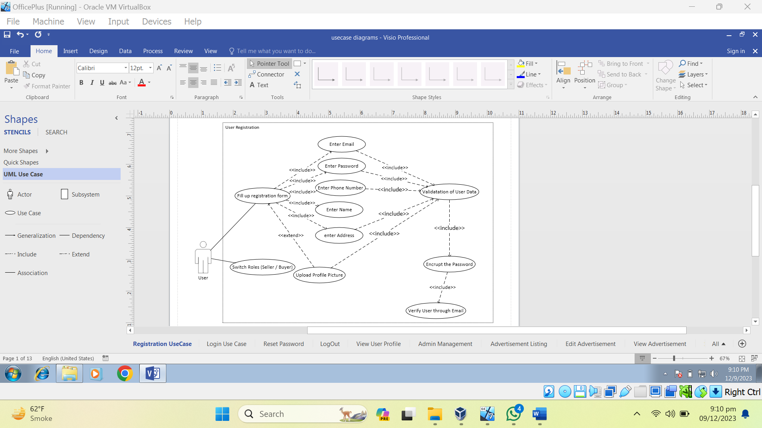

Use Case Diagram 1 User Registration

### User Log In

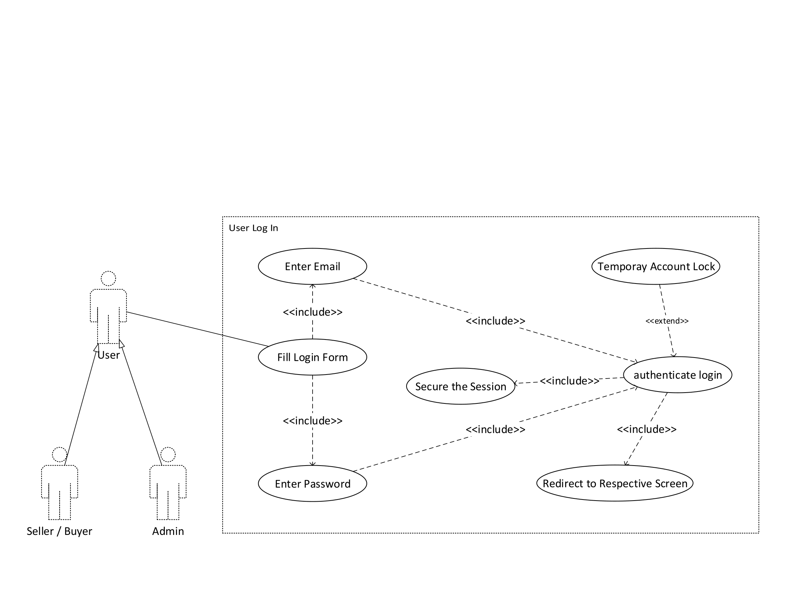

Use Case Diagram 2 User Login

### Reset Password

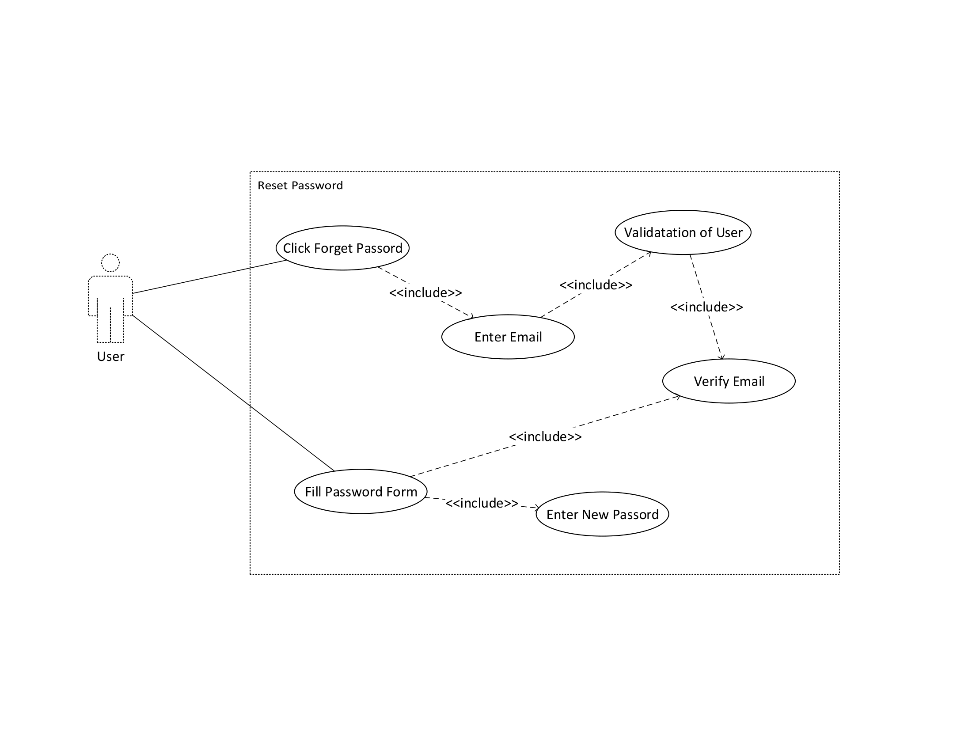

Use Case Diagram 3 Reset Password

### Admin Management

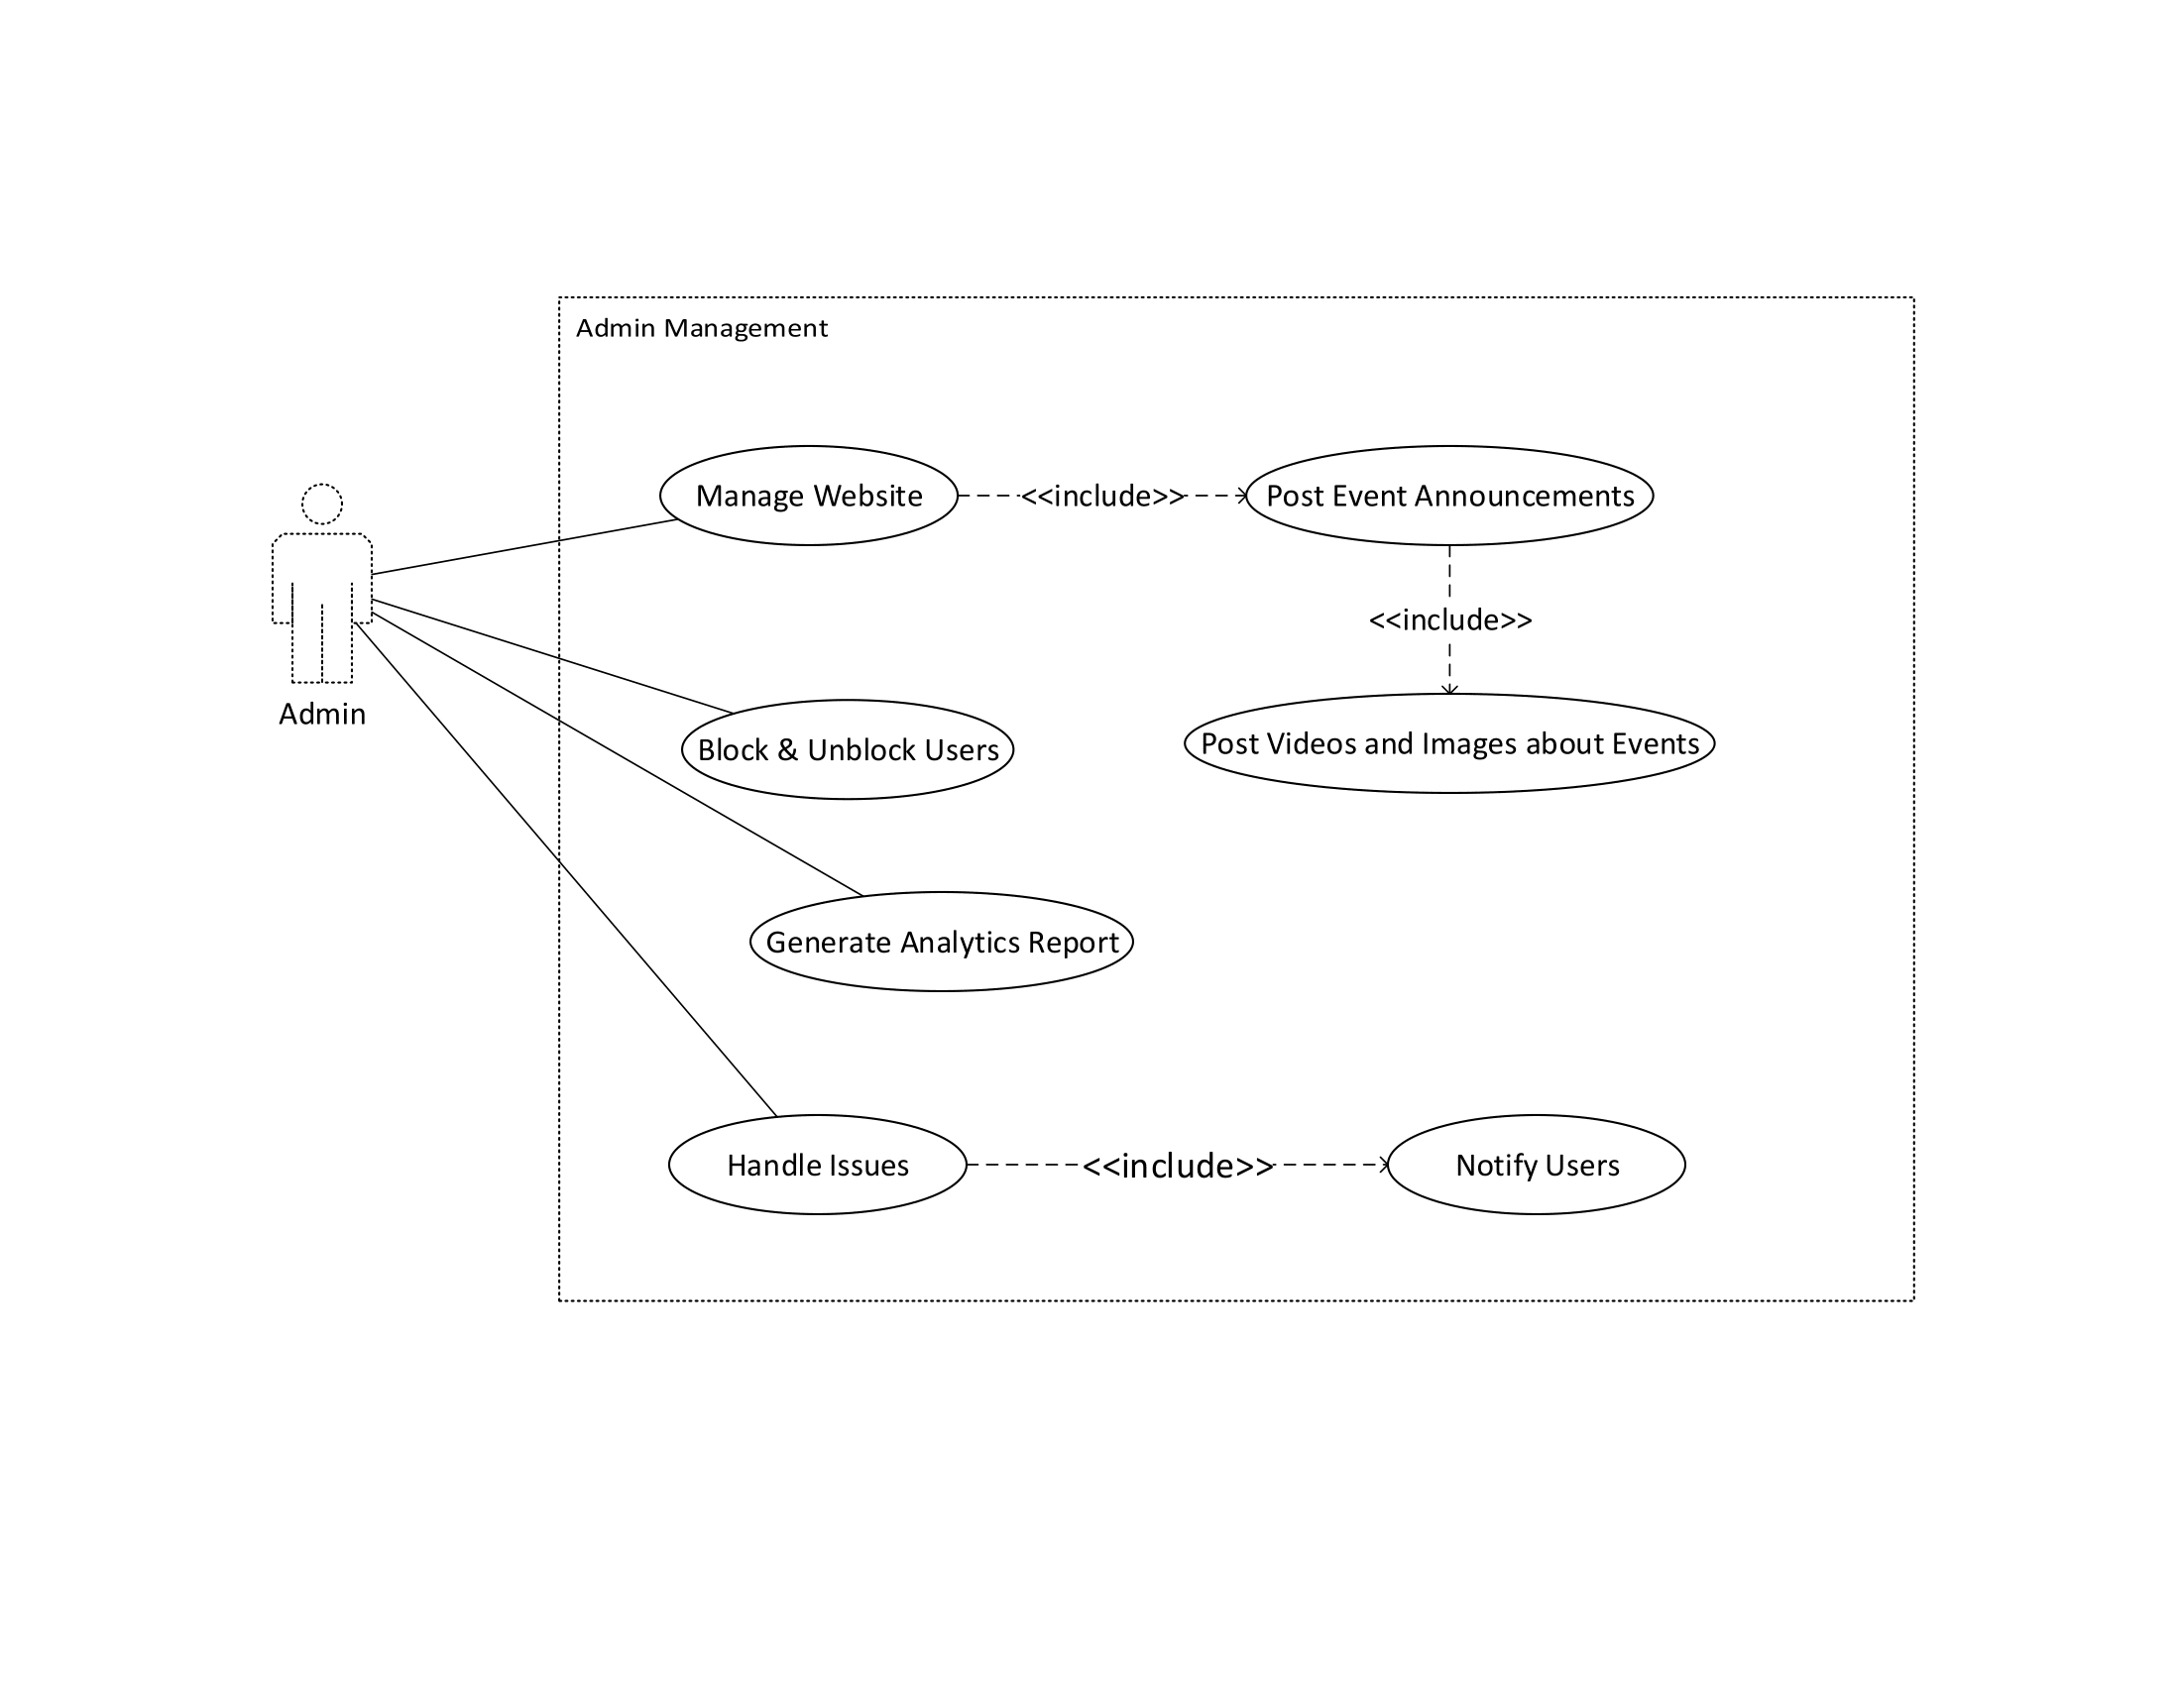

Use Case Diagram 4 Admin Management

### Create Listing Ad

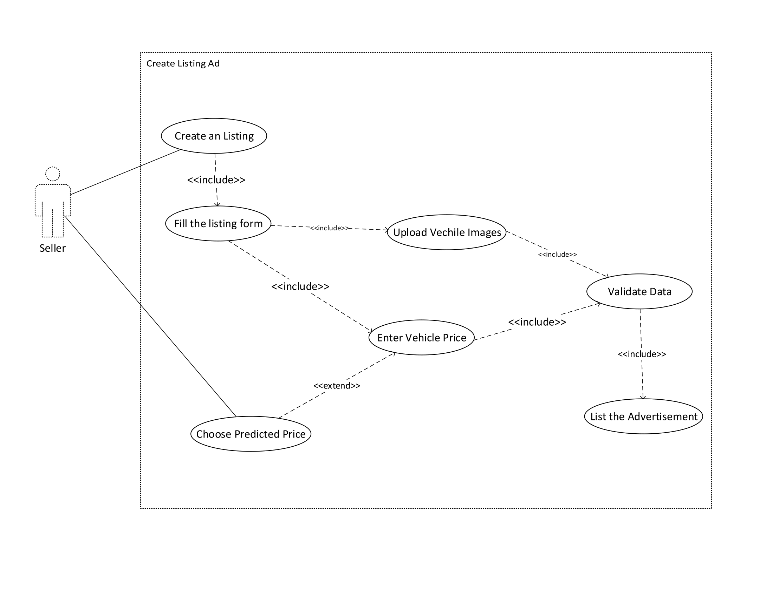

Use Case Diagram 5 Create Listing Ad

### Edit Listing

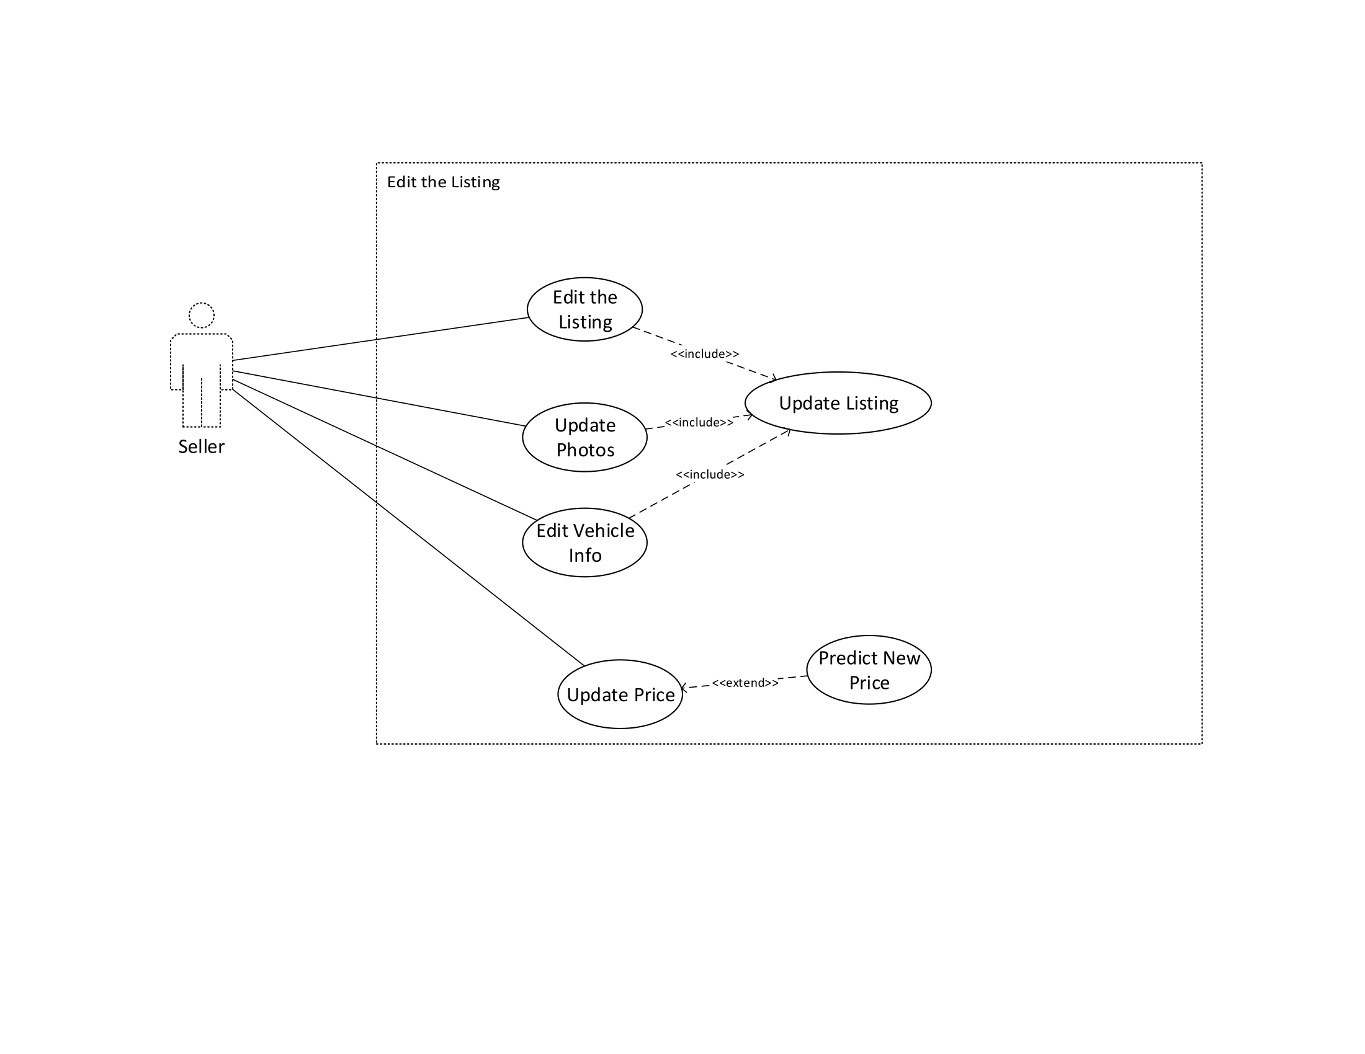

Use Case Diagram 6 Edit Listing

### Browse Listings

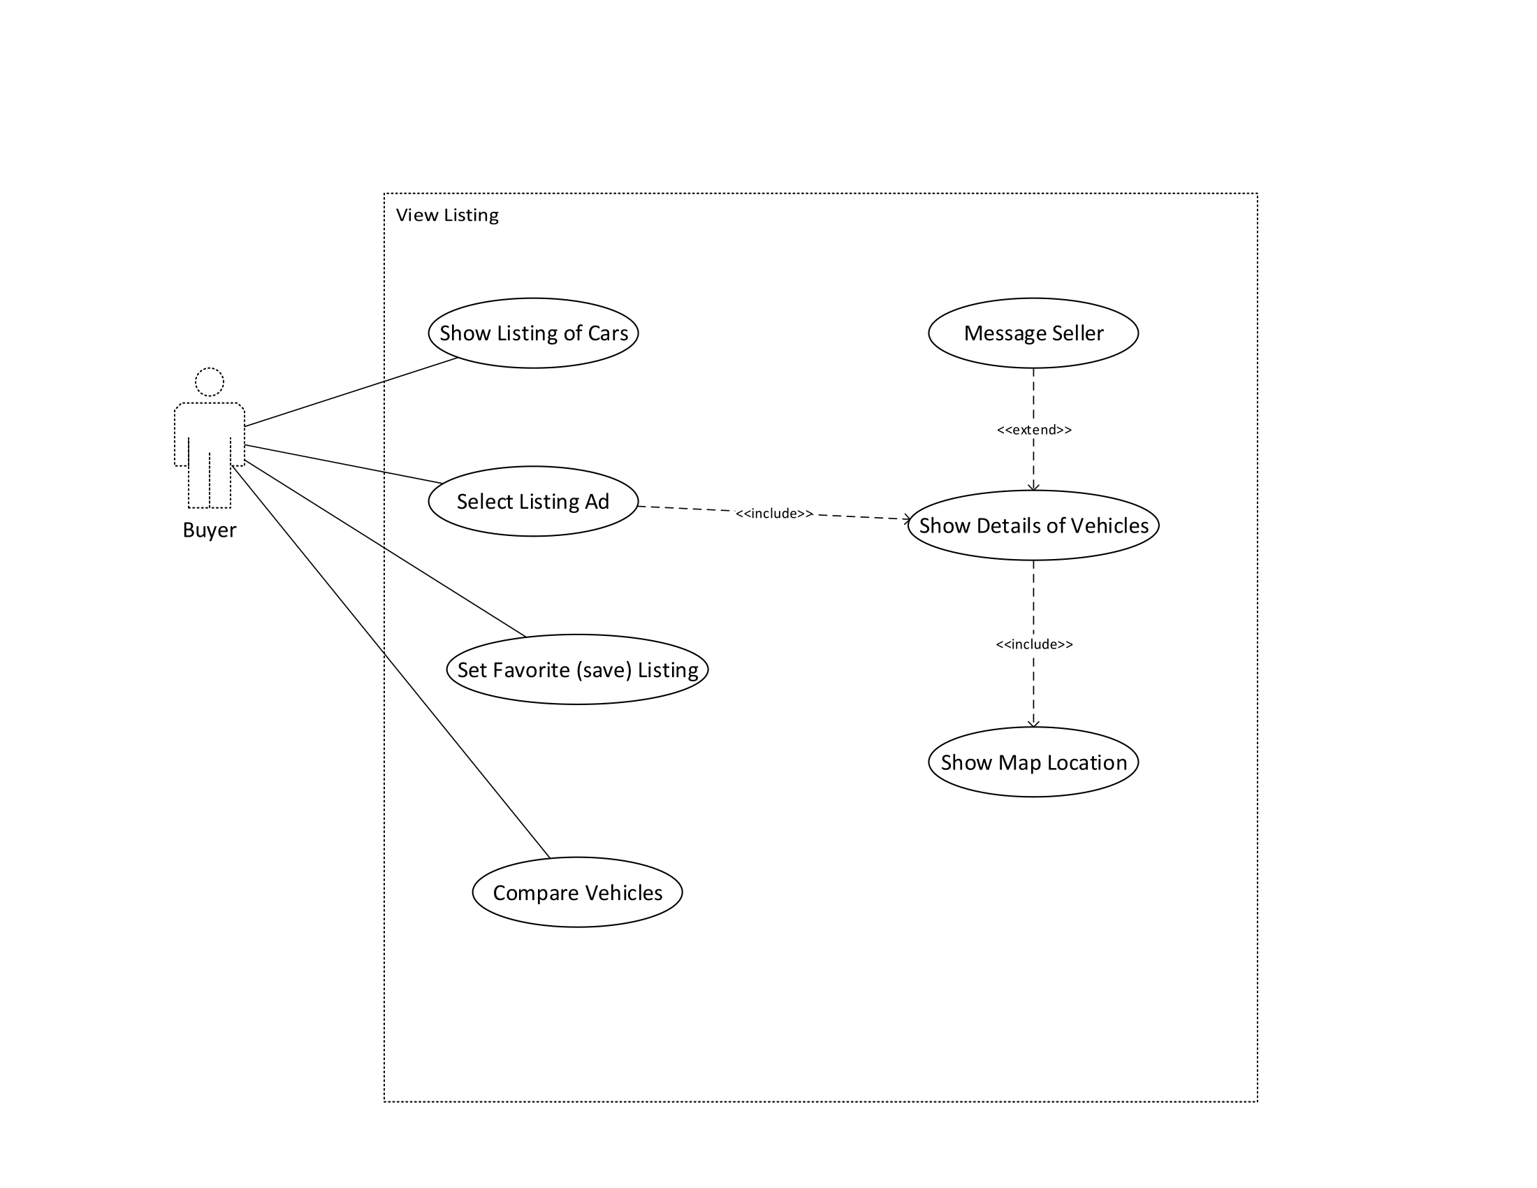

Use Case Diagram 7 Browse Listing

### Search and Filtering

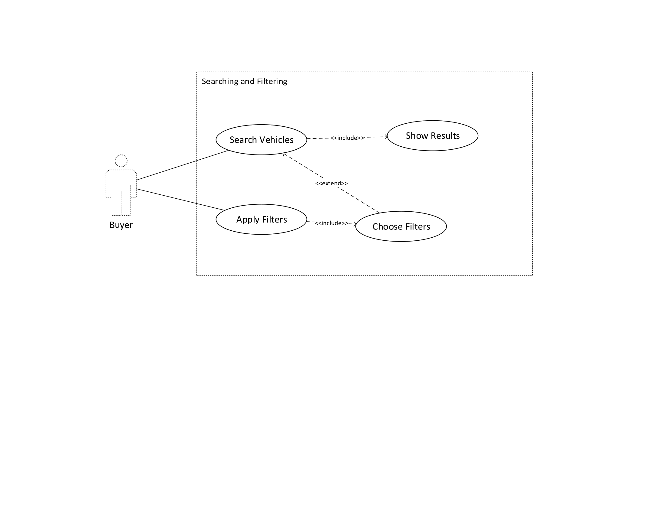

Use Case Diagram 8 Search and Filtering

### Contact and Messaging

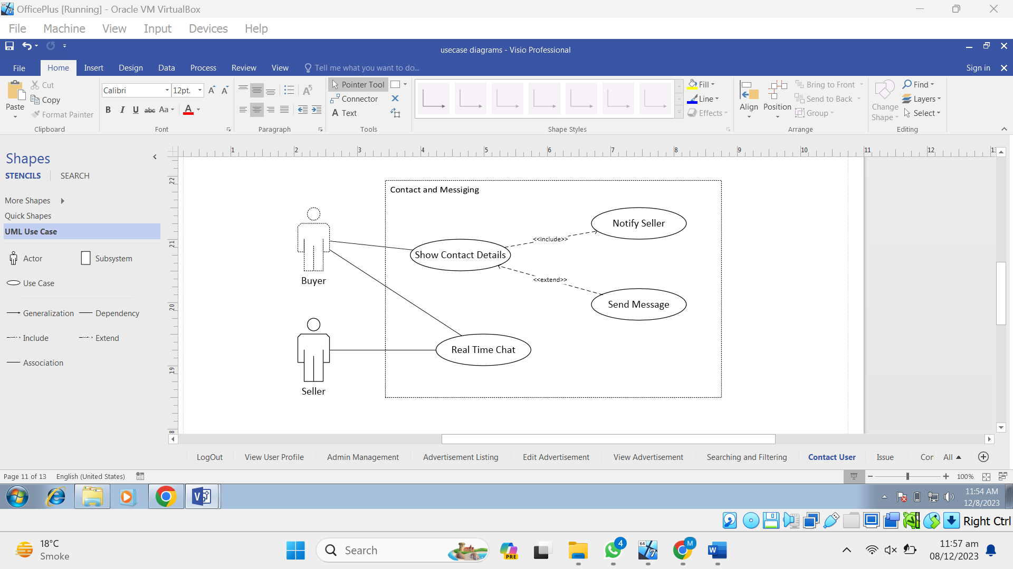

Use Case Diagram 9 Contact and Messaging

### Issue Reporting

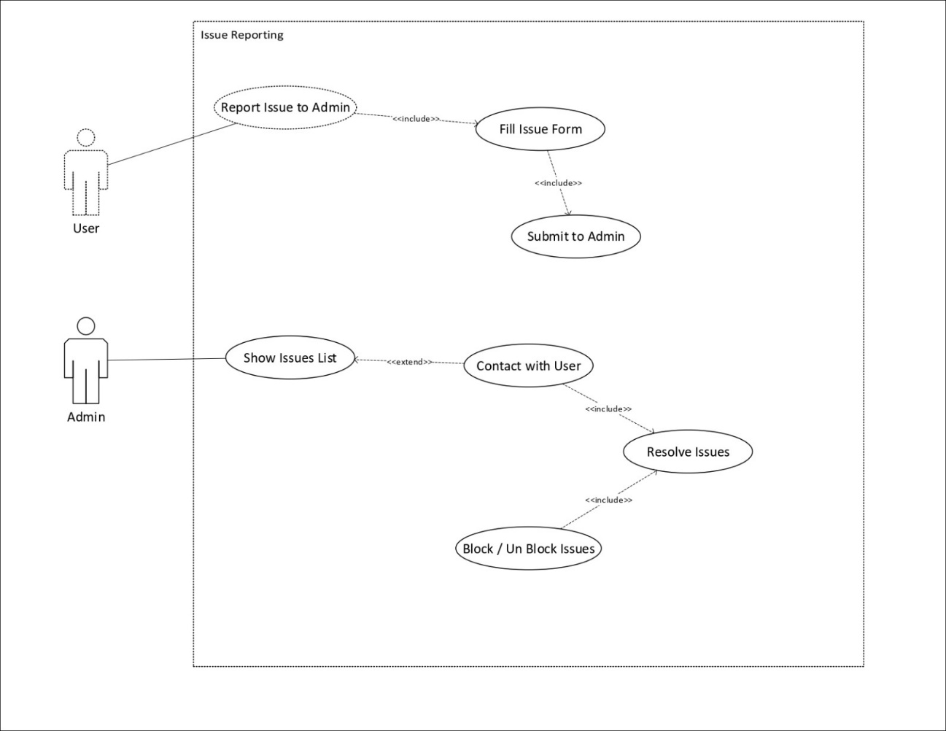

Use Case Diagram 10 Reporting Issue

### Interact Community

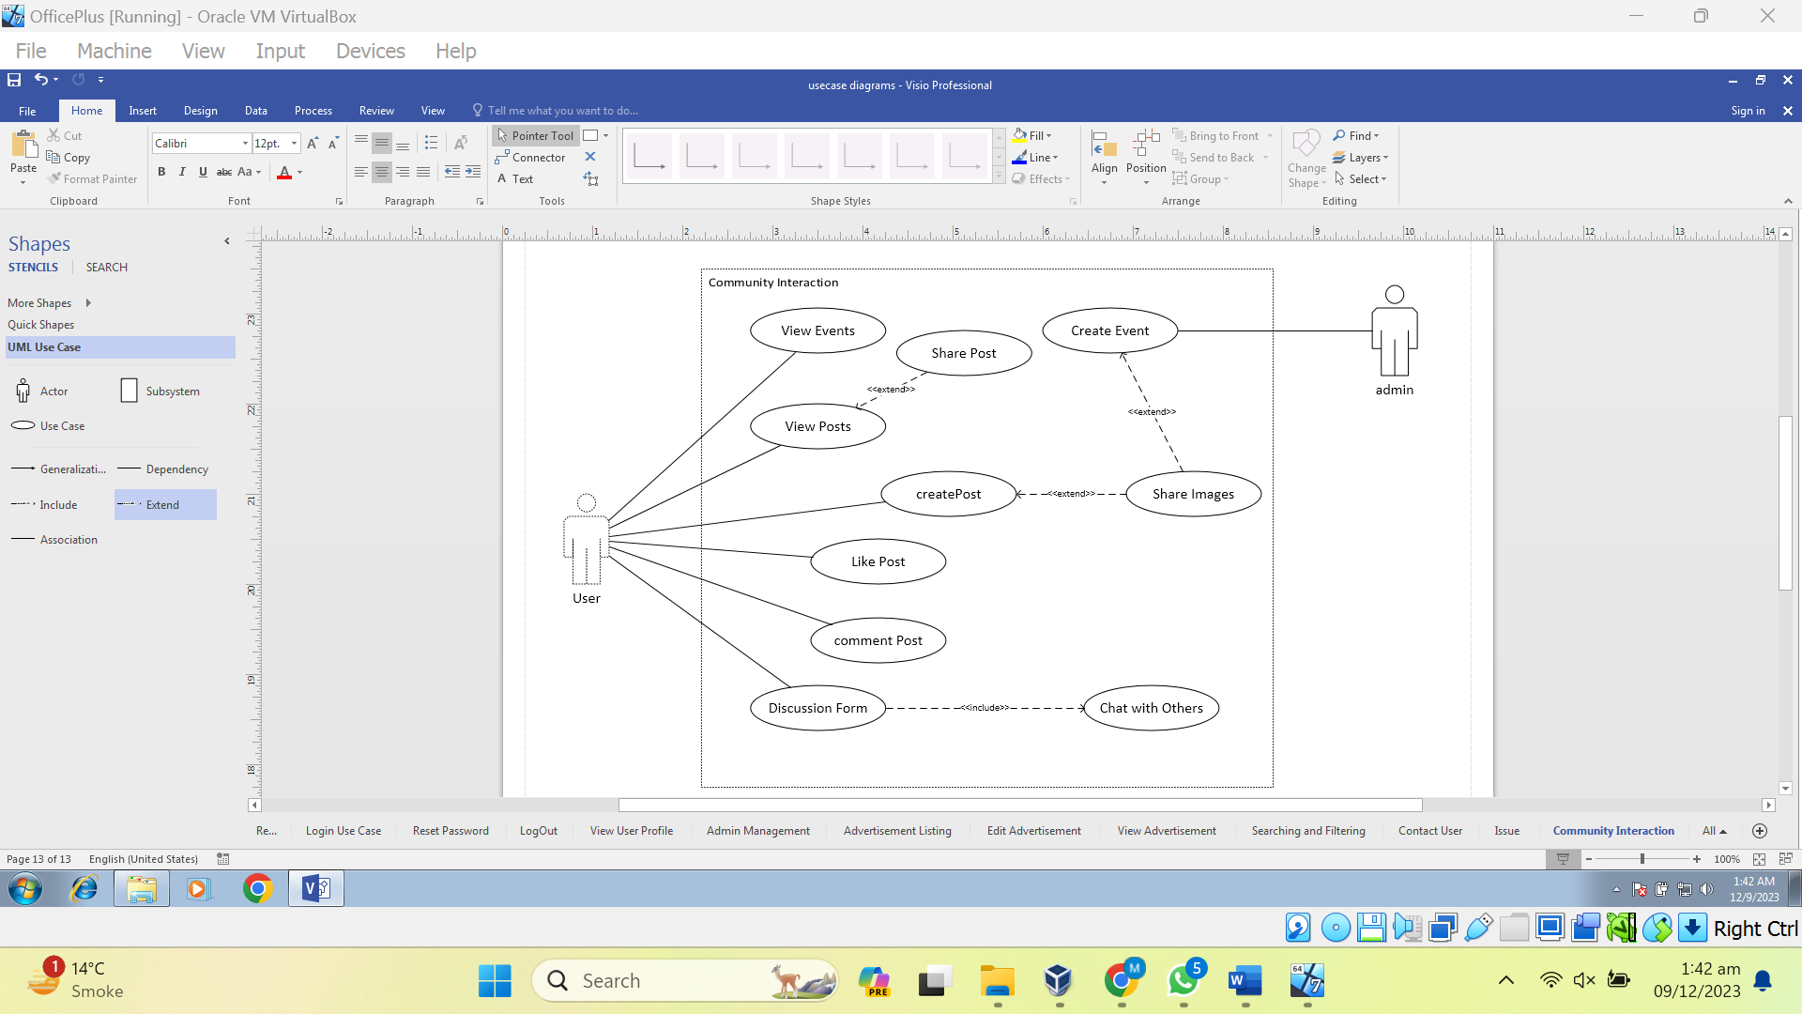

Use Case Diagram 11 Community Interaction

## Software Development Life cycle and Justification

DriveNet Project recognizes the need for an adaptive and iterative approach to software development and has chosen Agile Scrum as the preferred methodology for the project, with a particular focus on the Price Prediction, Community, and Listing modules.

### Justification for Agile Scrum Adoption in DriveNet:

#### Iterative Development in Price Prediction Module:

*Continuous Improvement:* Agile Scrum supports iterative development in the Price Prediction module, allowing for regular reviews and adjustments to the vehicle valuation algorithm based on changing requirements.

*Flexibility:* Scrum's iterative approach accommodates evolving insights and ensures the algorithm adapts to dynamic market conditions.

#### User-Centric Community Module Development:

*User Feedback Integration:* Scrum emphasizes regular feedback from end-users, aligning with the development of the Community module. This allows the team to create a platform that resonates with user preferences and expectations.

*Adaptation to Changing Community Needs*: Scrum's responsiveness ensures that the Community module evolves alongside the changing needs and expectations of the user community.

#### Dynamic Listing Module Planning:

*Prioritized Feature Development:* The Listing module benefits from Scrum's prioritization of features based on user value. This ensures that the most valuable listing features are developed and delivered early in the project. Like Price prediction module is first priority, then comes other features.

*Adjustable Project Planning:* Scrum's adaptability accommodates changes in the scope and priorities of the Listing module, responding to market trends and user demands.

#### Cross-Functional Collaboration for Problem Resolution:

*Collaborative Problem Solving:* Scrum encourages cross-functional collaboration, enabling quick and effective problem resolution across all modules.

*Continuous Communication:* Scrum ceremonies such as Daily Standups and Sprint Reviews promote continuous communication, allowing the team to address issues promptly and maintain project momentum.

#### Visibility and Transparency in Agile Scrum:

*Increased Visibility*: Scrum's emphasis on transparency ensures that the progress of each module, including Price Prediction, Community, and Listing, is visible to all stakeholders. Our team members will be working on each module along-side, so progress of each module need to be addressed.

*Enhanced Project Control:* Regular Sprint Reviews and Backlog Grooming sessions empower DriveNet to maintain control over the project's direction, ensuring alignment with business goals.

### Summary:

In summary, DriveNet has strategically embraced Agile Scrum, leveraging its iterative and user-centric approach to enhance the development of the Price Prediction, Community, and Listing modules. The methodology's flexibility, collaboration, and transparency align with DriveNet's commitment to delivering a dynamic and user-focused web application, with reliable predicted price for the vehicles.

# Chapter 3 - System Design

## Work Breakdown Structure Diagram

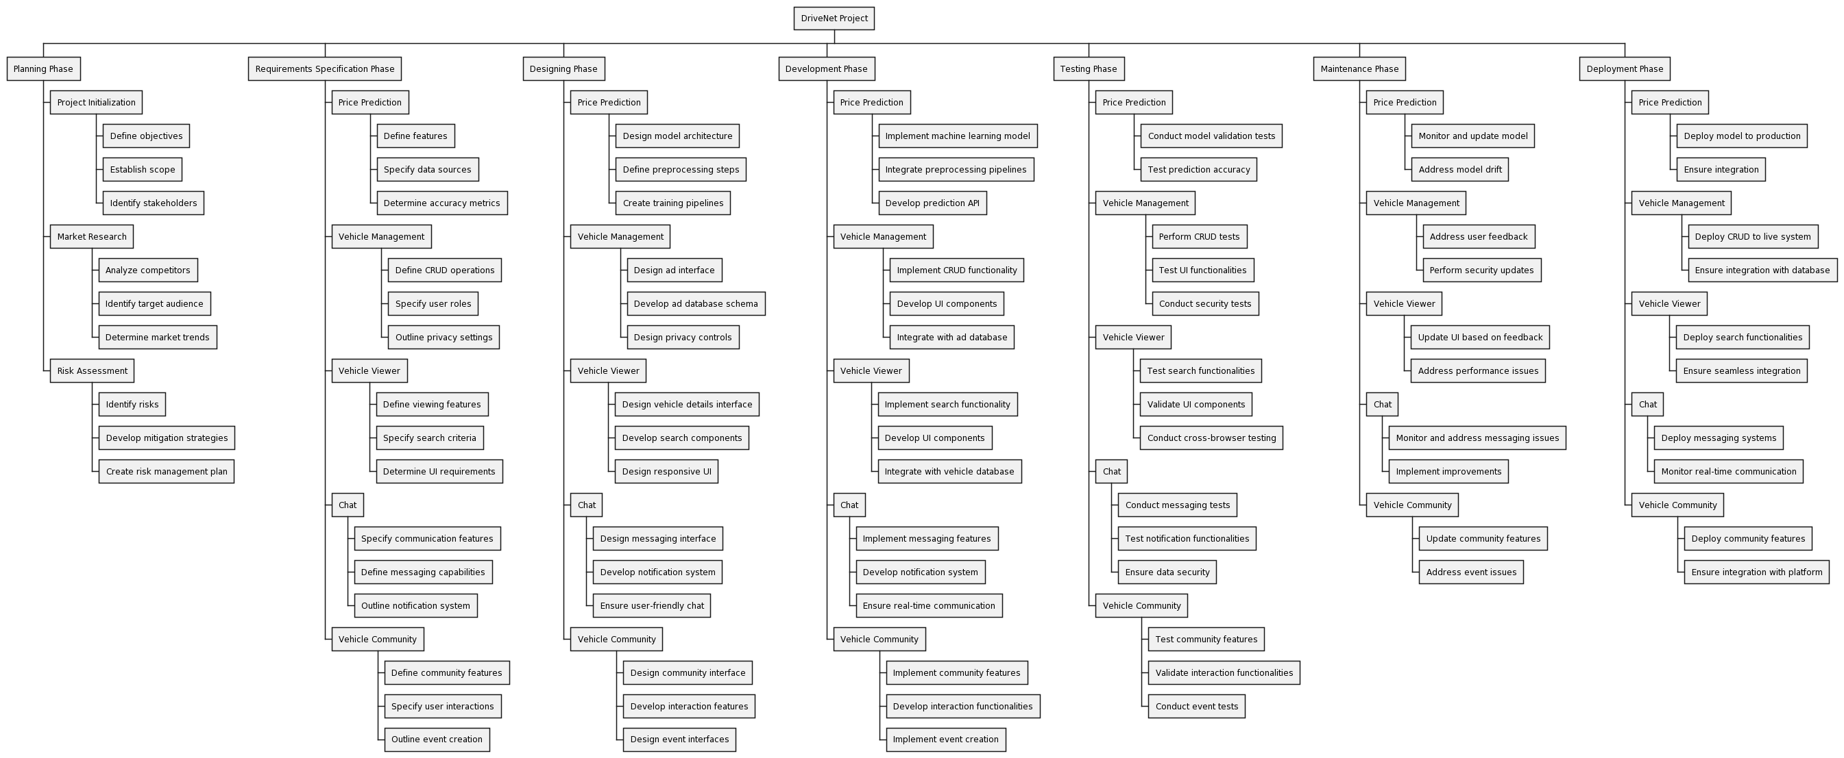

Figure 1 WBS Diagram

## Activity Diagrams

### User Registration

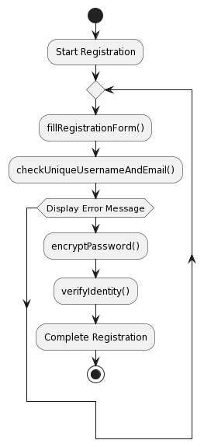

Activity Diagram 1 User Registration

### User Login

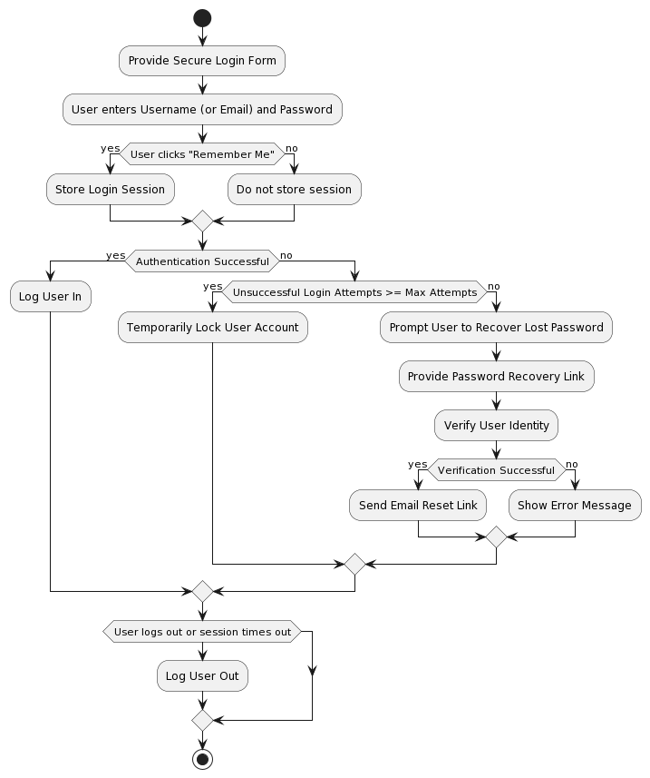

Activity Diagram 2 User Login

### Listing Ad Activity

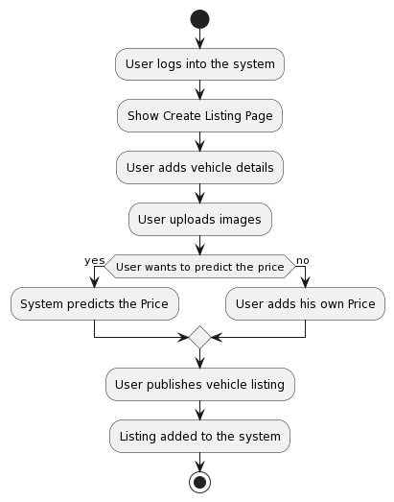

Activity Diagram 3 Listing Vehicle

### Edit Vehicle Listing Activity

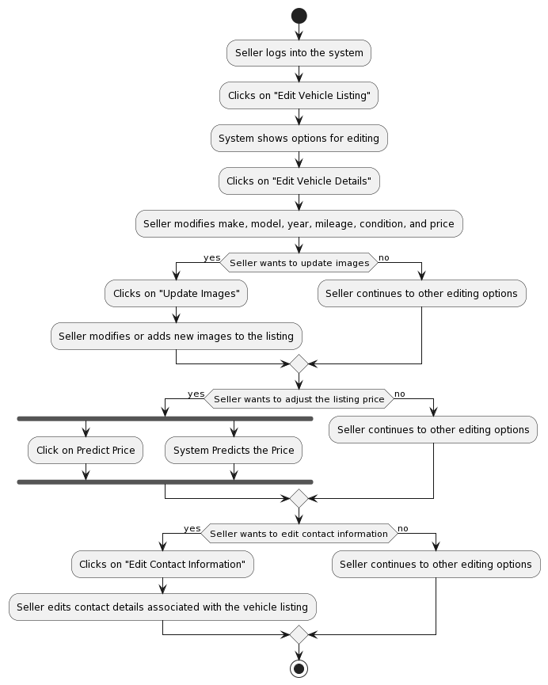

Activity Diagram 4 Edit Vehicle Listing

### Price Prediction Activity

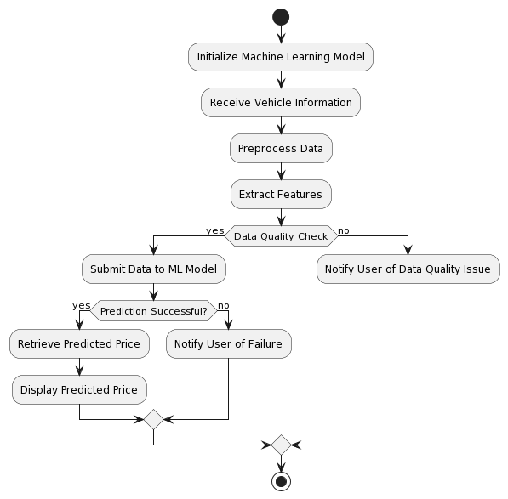

Activity Diagram 5 Price Prediction

### Vehicle Browsing and Buying

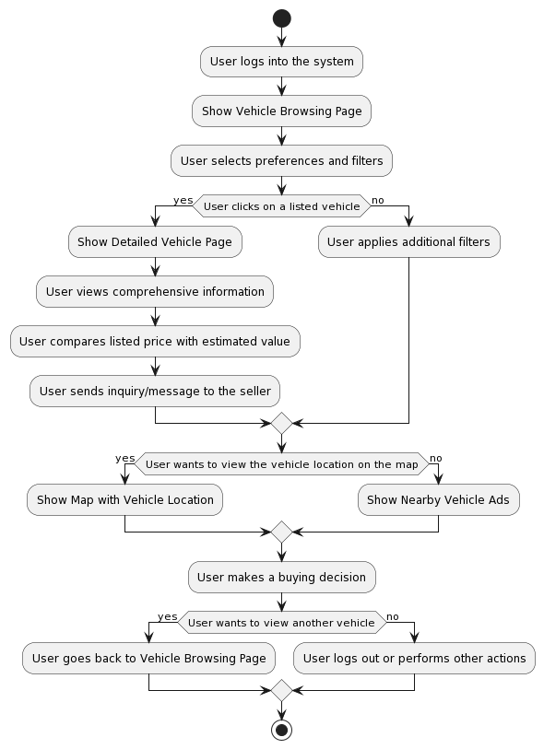

Activity Diagram 6 Vehicle Browsing and Buying

### Search and filtering

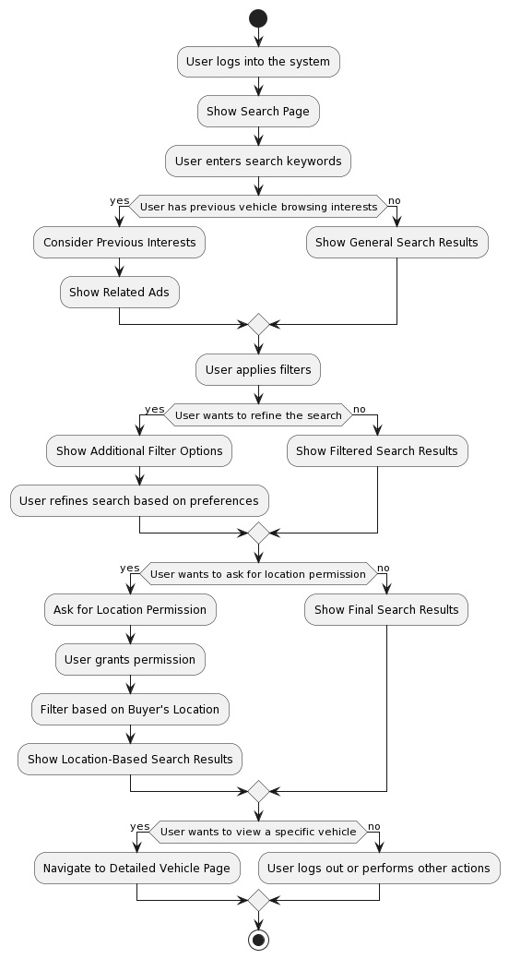

Activity Diagram 7 Search and Filtering

### Contact and Messaging

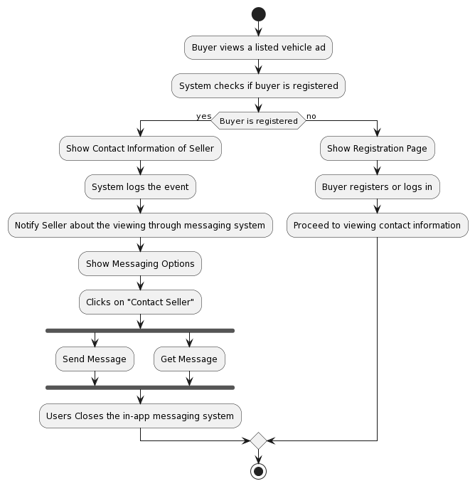

Activity Diagram 8 Contract and Messaging

### Saving and Comparison

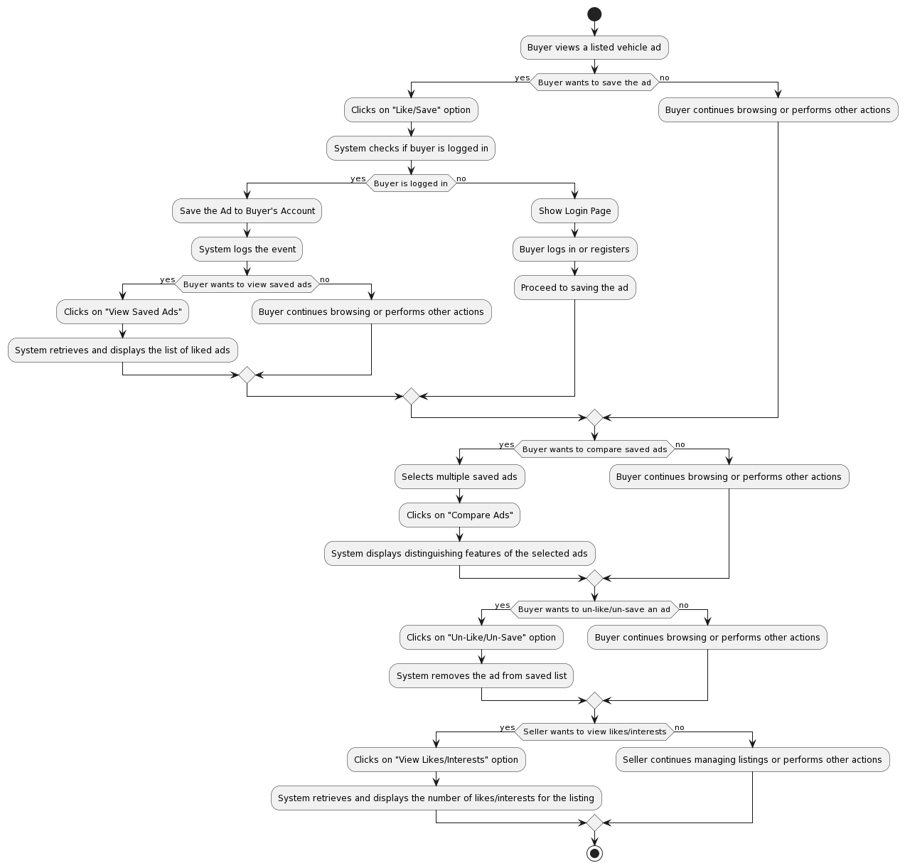

Activity Diagram 9 Saving and Comparison

### Admin: Issue Reporting Activity

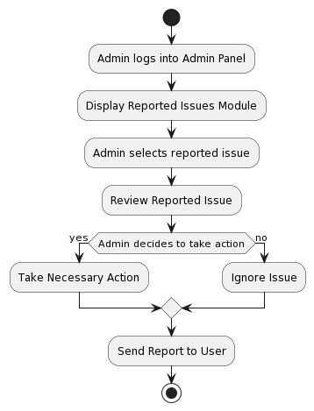

Activity Diagram 10 Reporting Issue

### Admin: Event Handling Activity

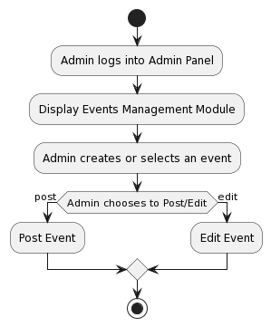

Activity Diagram 11 Event Handling

### User: Issue Reporting

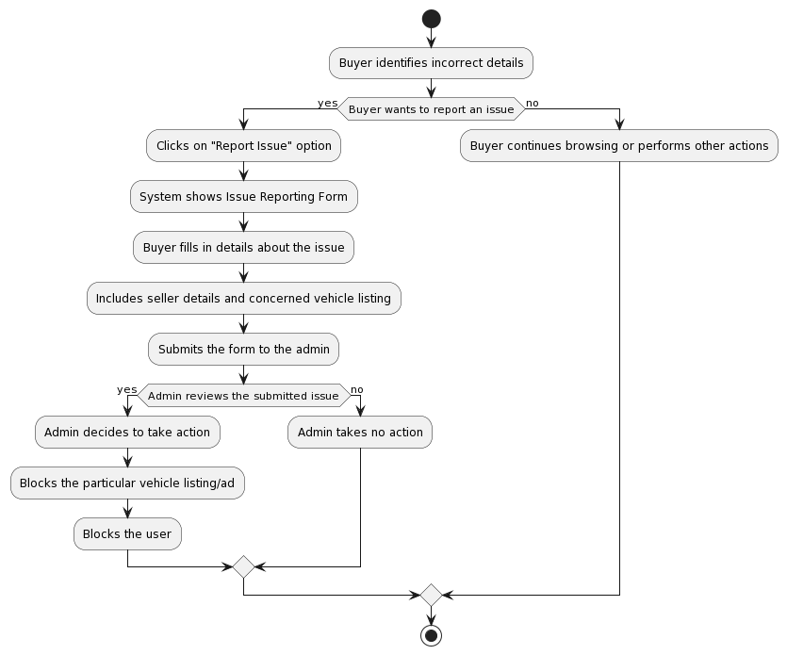

Activity Diagram 12 Issue Reporting

### Community Interaction Module

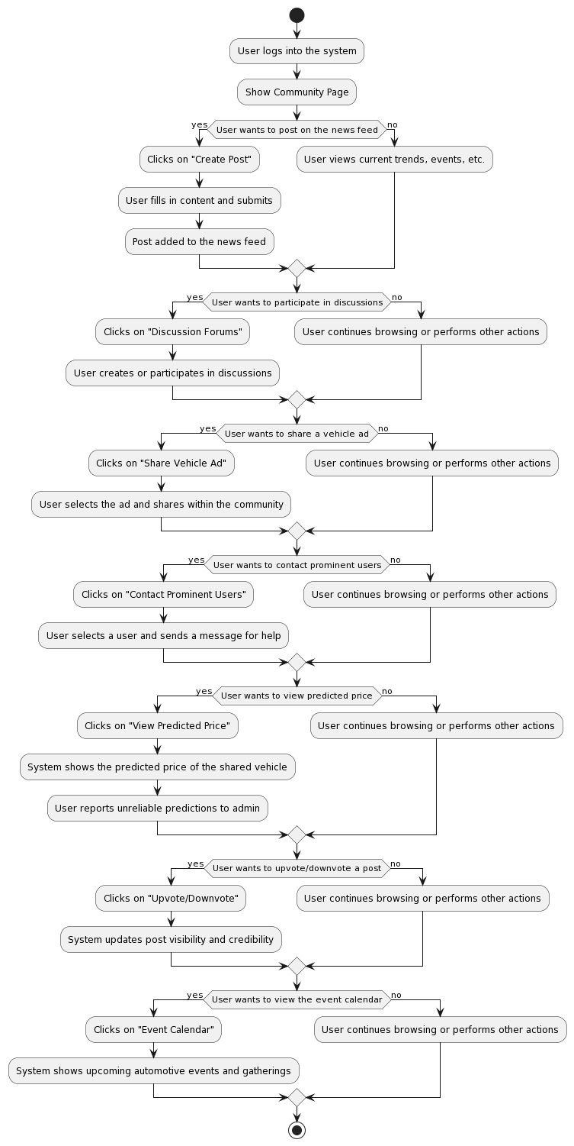

Activity Diagram 13 Community Interaction

### Analytics

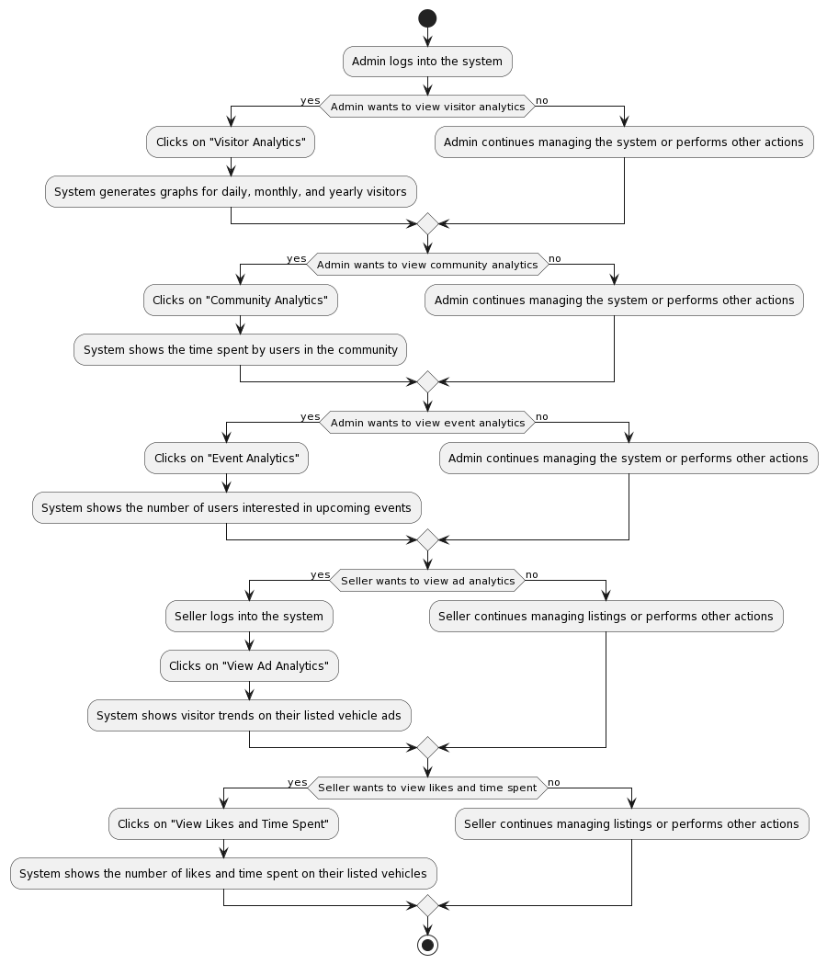

Activity Diagram 14 View Analytics

## Sequence Diagram

### Registration Sequence

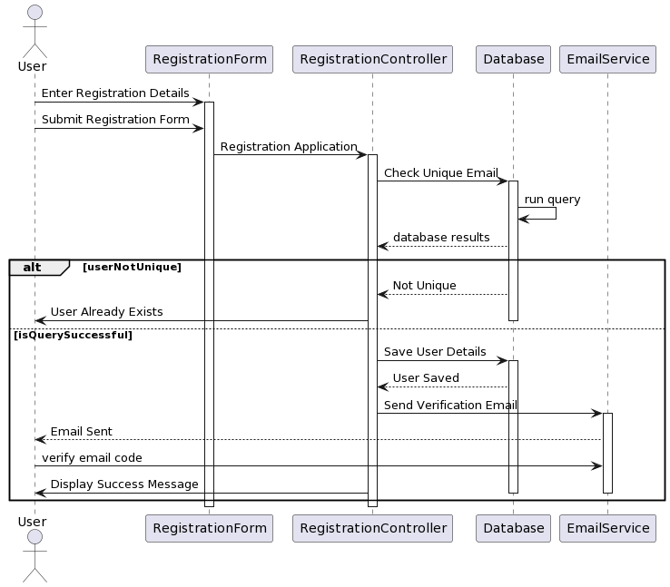

Sequence Diagram 1 Registration

### Login Sequence

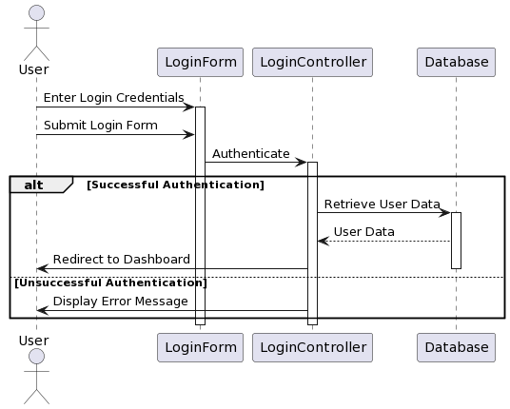

Sequence Diagram 2 Login

### Create Vehicle Listing Sequence

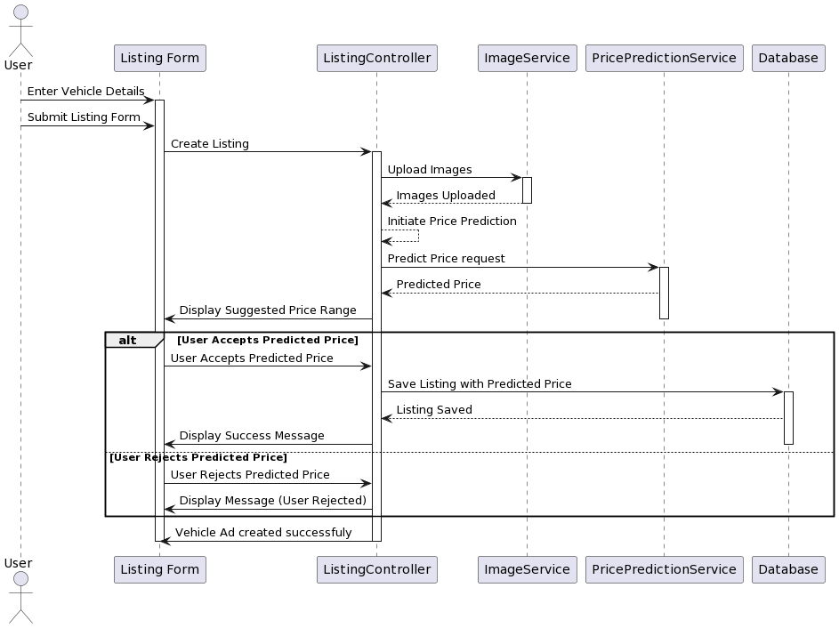

Sequence Diagram 3 Create Vehicle Listing

### Edit Vehicle Listing

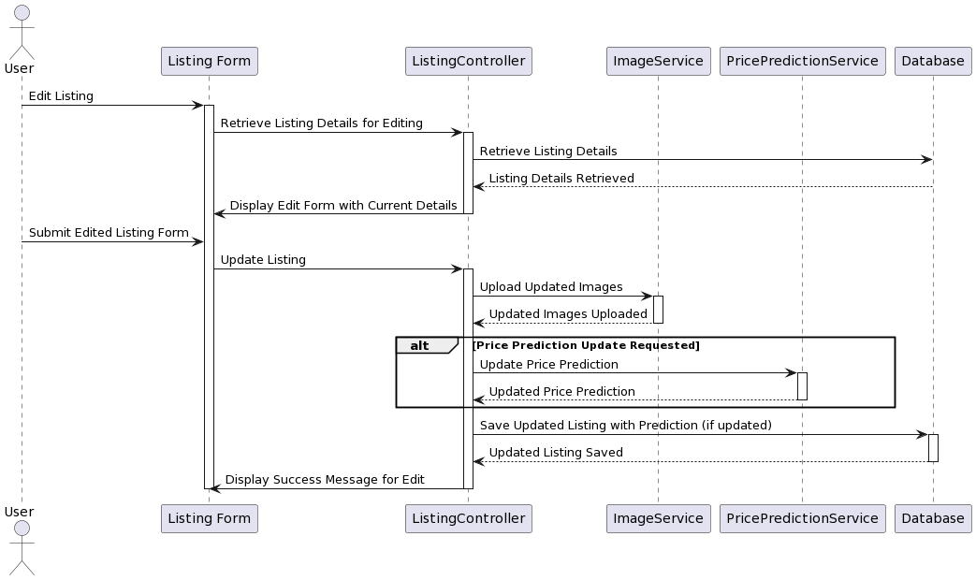

Sequence Diagram 4 Edit Vehicle Listing

### Vehicle browsing and buying

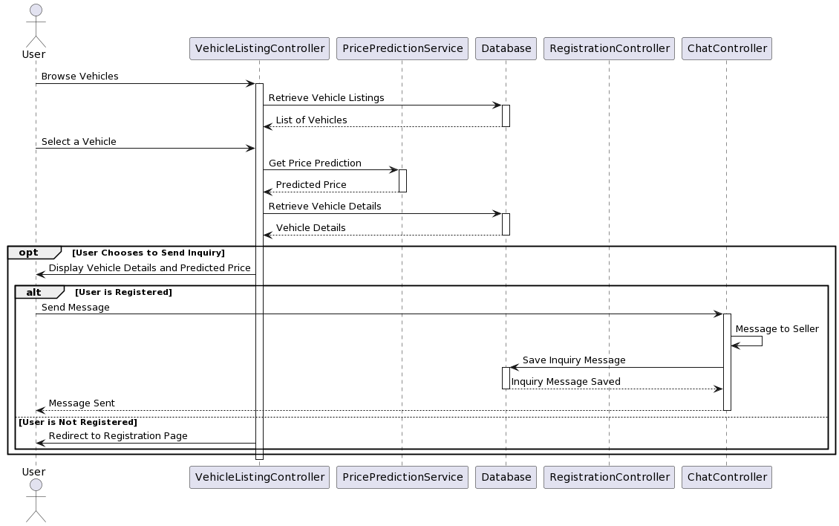

Sequence Diagram 5 Vehicle buying

### Price Prediction Sequence

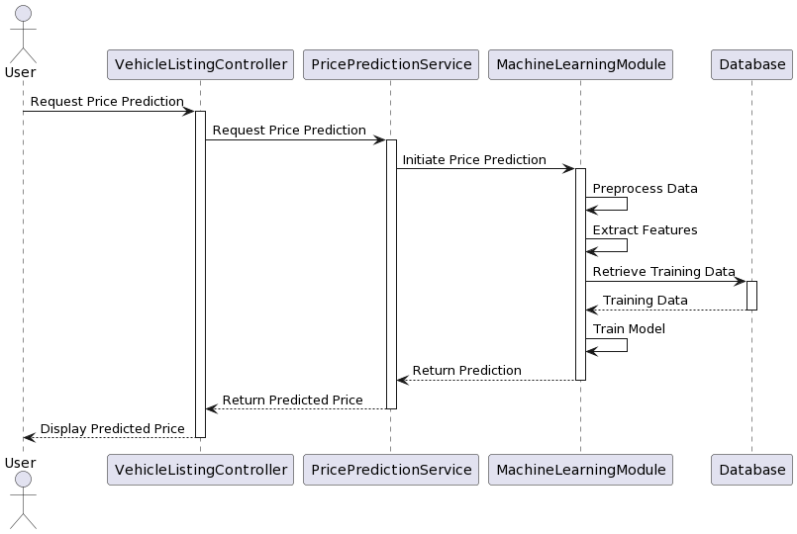

### Chatting Sequence

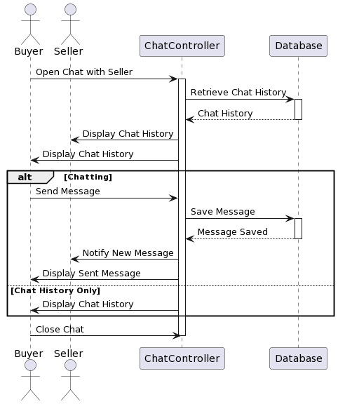

Sequence Diagram 6 chatting sequence

### Search and Filtering Sequence

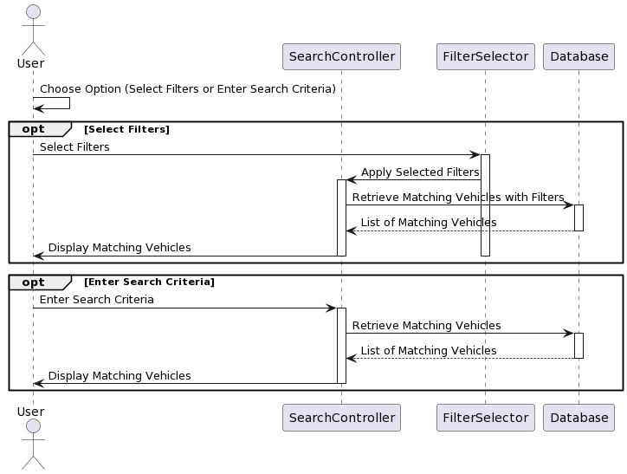

Sequence Diagram 7 Search and filter

### Save and Comparing Sequence

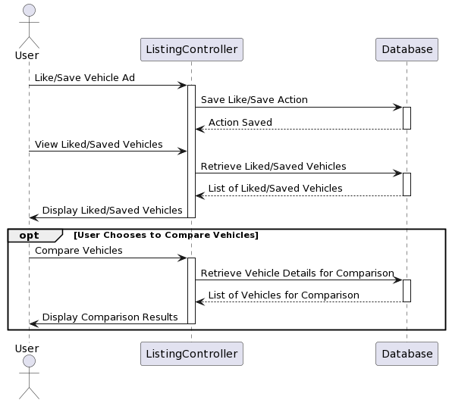

Sequence Diagram 8 Save and compare

### Report Issue

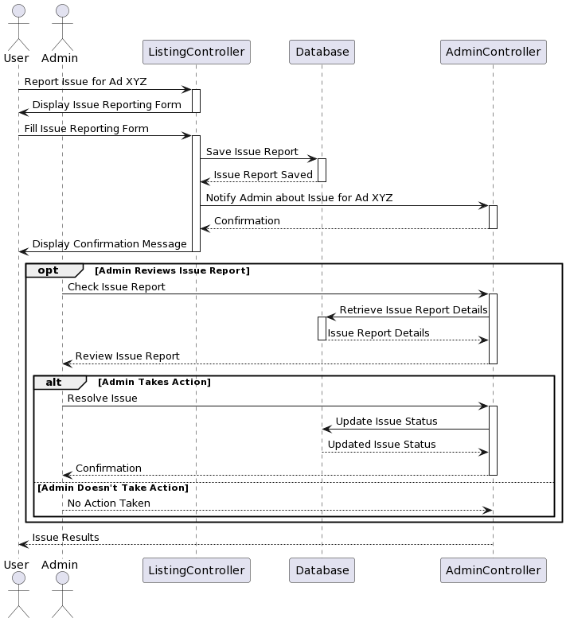

Sequence Diagram 9 Report Issue

### Interact with community Sequence

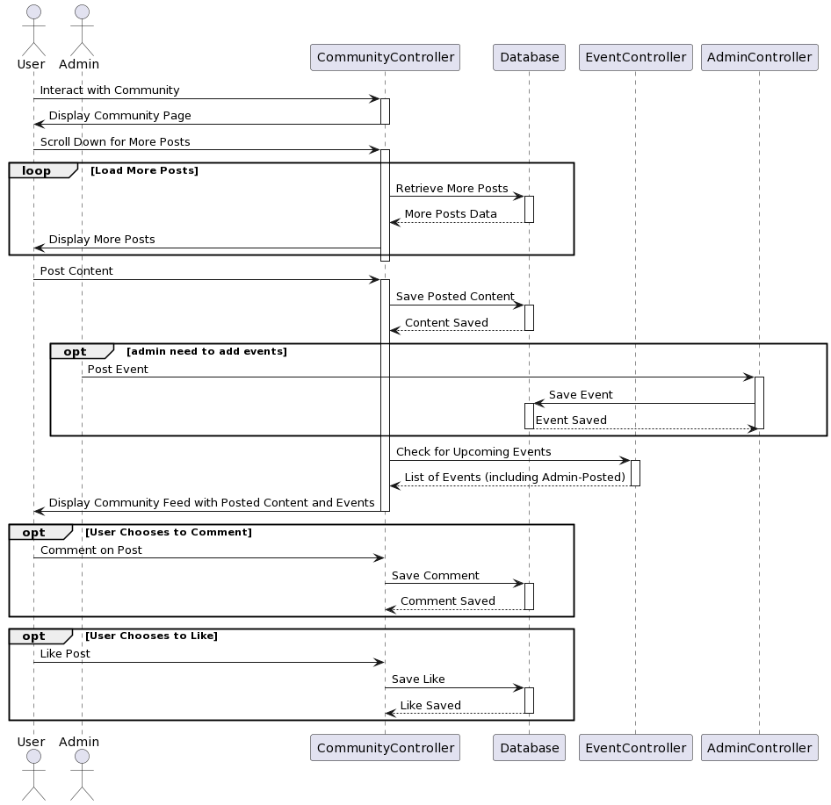

Sequence Diagram 10 Interact with community

### View Analytics

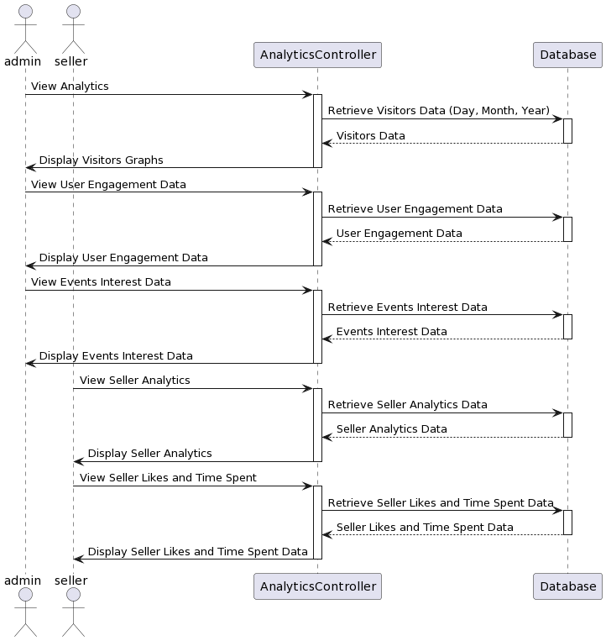

Sequence Diagram 11 View Analytics

## Collaboration Diagrams

### Registration Collaboration

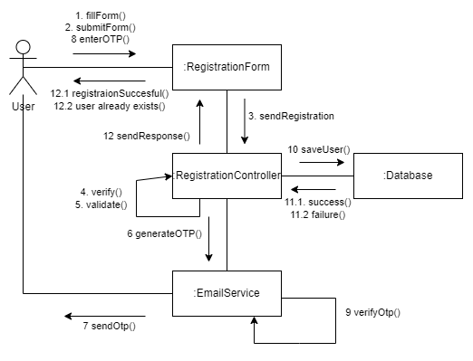

Collaboration Diagram 1 User Registration

### Login Collaboration

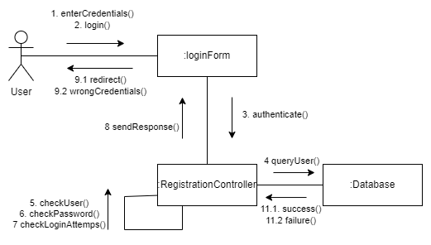

Collaboration Diagram 2 Login User

### Create Vehicle Listing Collaboration

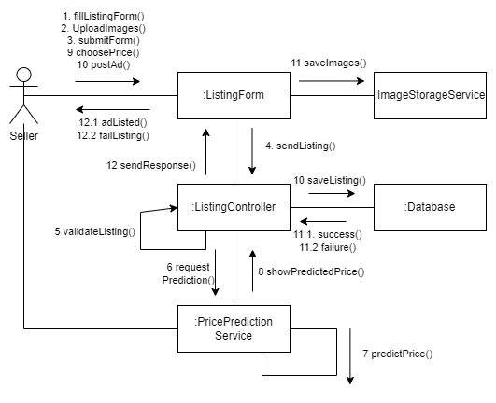

Collaboration Diagram 3 Vehicle Listing

### Edit Vehicle Listing Collaboration

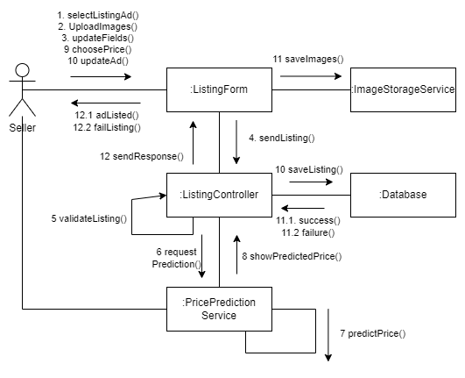

Collaboration Diagram 4 Edit Vehicle Listing

### Price Prediction Collaboration

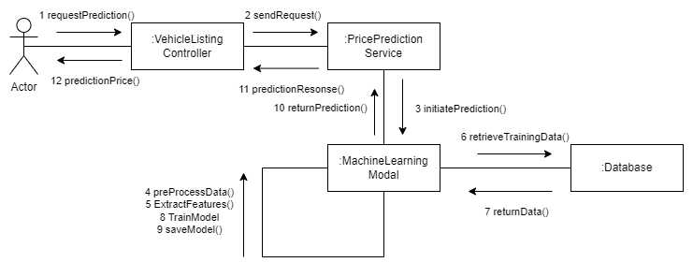

Collaboration Diagram 5 Price Prediction

### Browsing and Buying Collaboration

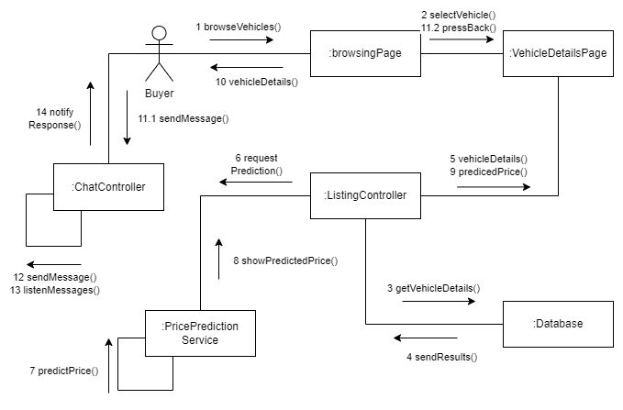

Collaboration Diagram 6 Browsing and Buying

### Chat and Messaging Collaboration

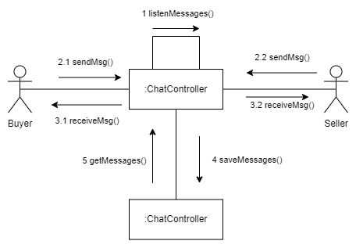

Collaboration Diagram 7 Chat and Messaging

### Search and Filtering Collaboration

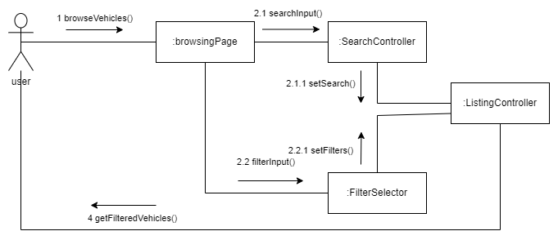

Collaboration Diagram 8 Search and Filtering

### Save and Comparing Collaboration

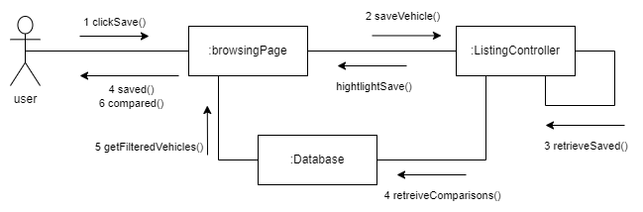

Collaboration Diagram 9 Saving and Comparing

### Issue Reporting Collaboration

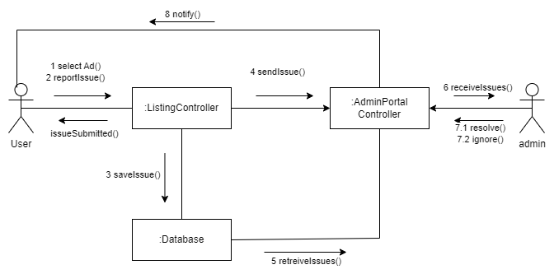

Collaboration Diagram 10 Issue Reporting

### Community Interaction Collaboration

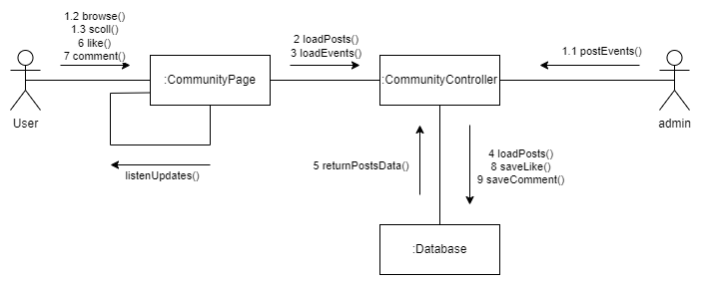

Collaboration Diagram 11 Community Interaction

### Generate Report Collaboration

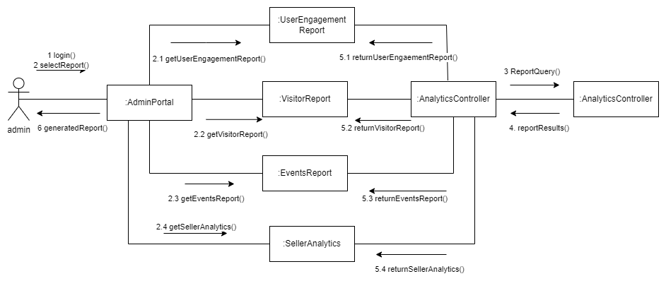

Collaboration Diagram 12 Generate Report

## Class Diagram

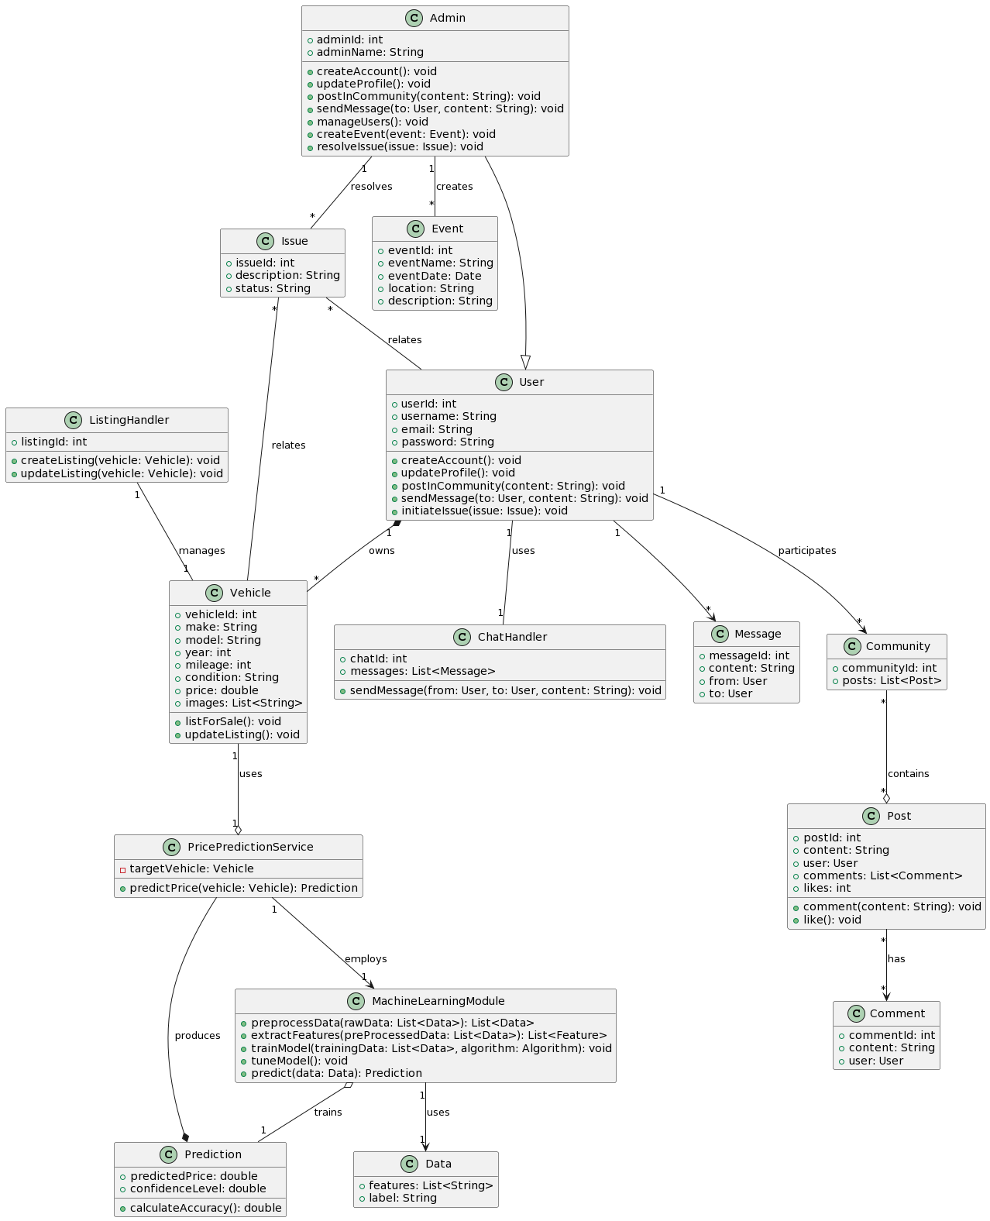

Figure 2 Class Diagram

## Architecture Diagram

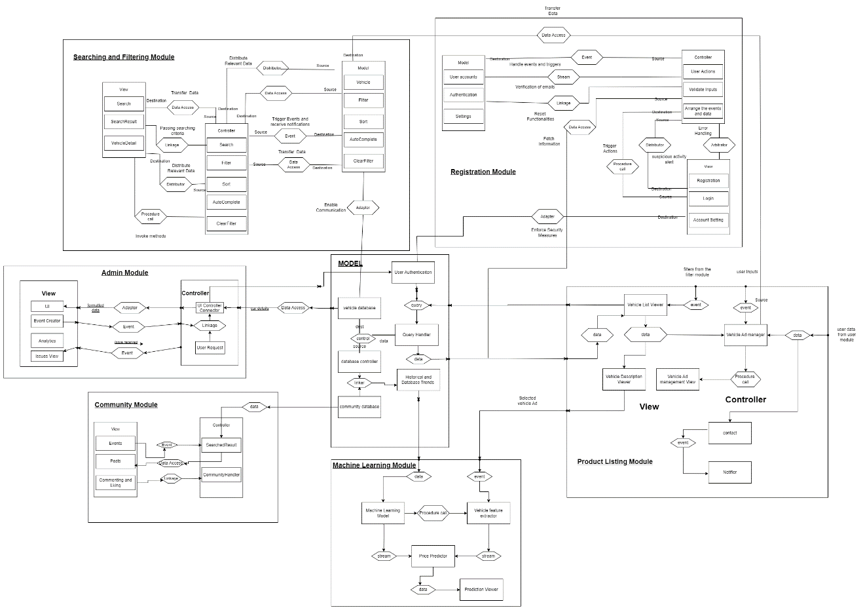

Figure 3 Architecture Diagram

## Database Diagram

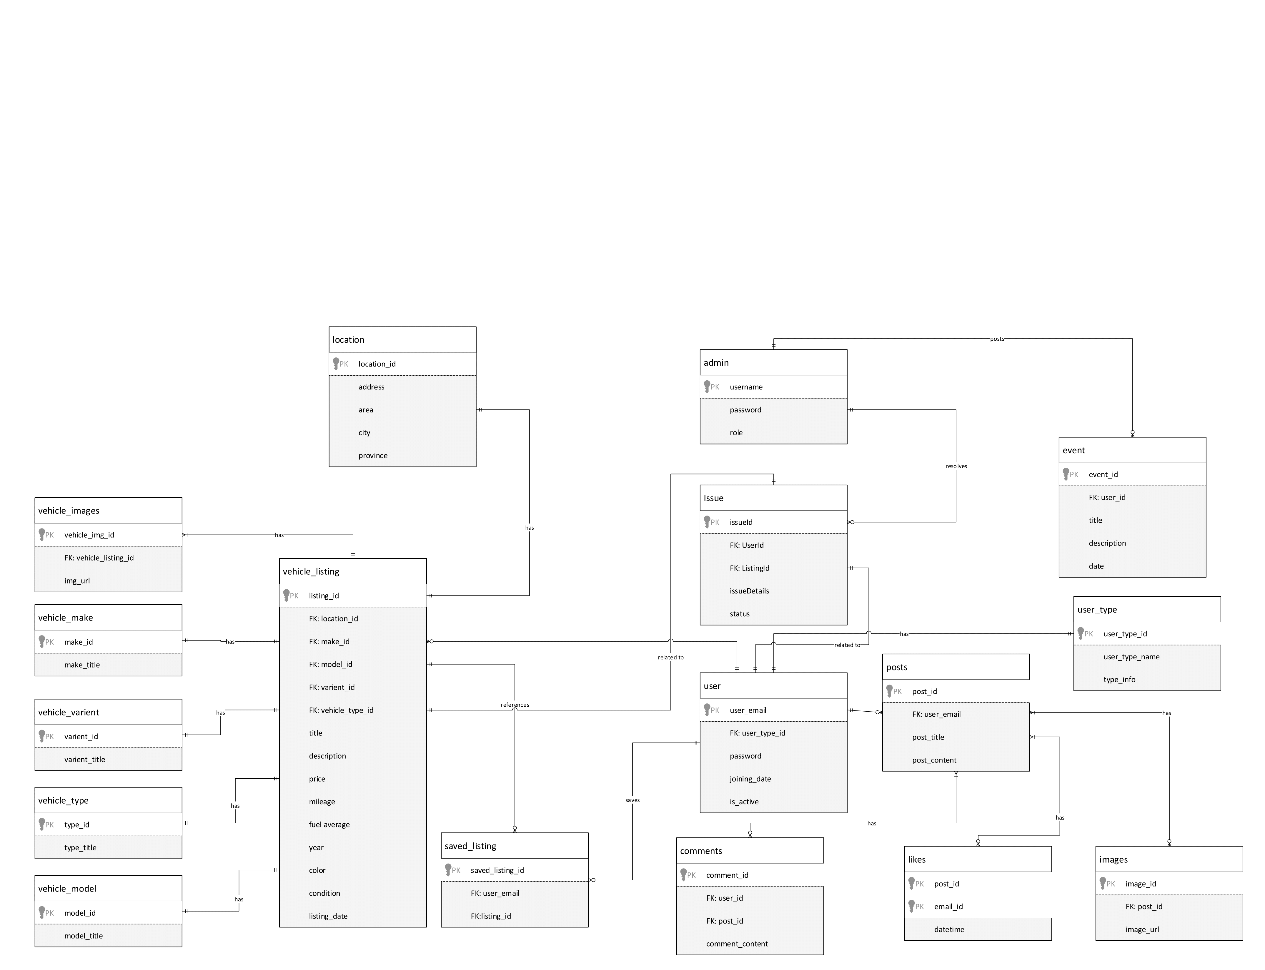

Figure 4 Database Diagram

# Chapter 4 - System Testing

## System Testing

* Test Cases
* Unit/Integration/User Acceptance Testing

## Test Cases

|  |  |
| --- | --- |
| * TC-01 | Test User registration |
| * TC-02 | Test User Login |
| * TC-03 | Test Forgot Password |
| * TC-04 | Test User profile Edit |
| * TC-05 | Test User management/admin panel |
| * TC-06 | Test Vehicle listing |
| * TC-06.1 | Test Editing Vehicle listing |
| * TC-07 | Test Vehicle browsing and buying |
| * TC-08 | Test Search and filtering |
| * TC-09 | Test Contact and messaging |
| * TC-10 | Test Saving and comparison |
| * TC-11 | Test Price prediction |
| * TC-12 | Test Issue reporting |
| * TC-13 | Test Community interaction and help |
| * TC-14 | Test Analytics |
| * TC-NF-01 | Performance |
| * TC-NF-02 | Reliability |
| * TC-NF-03 | Scalability |
| * TC-NF-04 | Availability |
| * TC-NF-05 | Security |
| * TC-NF-06 | Maintainability |
| * TC-NF-07 | Portability |
| * TC-NF-08 | Usability |
| * TC-NF-09 | Interoperability |
| * TC-NF-10 | Compliance |

## Unit Testing

### TC-01 User Registration

|  |  |
| --- | --- |
| **Test Case ID** | TC-01 |
| **Name of Use Case** | User Registration |
| **Actor** | User |
| **Description** | Test the registration process for new users. |
| **Pre-Condition** | The user is not already registered. |
| **Post-Condition** | The user is successfully registered in the system. |
| **Event 1** | User navigates to the registration form. |
| **Event 2** | User fills in required fields (name, email, password, etc.). |
| **Event 3** | User submits the registration form. |
| **Event 4** | System validates and registers the user. |
| **Alternative Flow** | If registration fails, the system shows an error message. |

Table 25 TC-01 User Registration

### TC-02 User Login

|  |  |
| --- | --- |
| **Test Case ID** | TC-02 |
| **Name of Use Case** | User Login |
| **Actor** | User |
| **Description** | Test the login functionality for existing users. |
| **Pre-Condition** | The user is already registered. |
| **Post-Condition** | The user is logged in and directed to the user dashboard. |
| **Event 1** | User navigates to the login page. |
| **Event 2** | User enters registered email and password. |
| **Event 3** | User clicks the login button. |
| **Event 4** | System validates credentials and logs the user in. |
| **Alternative Flow** | If login fails, the system shows an error message. |

Table 26 TC-02 User Login

### TC-03 Forgot Password

|  |  |
| --- | --- |
| **Test Case ID** | TC-03 |
| **Name of Use Case** | Password Reset |
| **Actor** | User |
| **Description** | Test the password reset functionality for users who forget it. |
| **Pre-Condition** | User has a registered account but forgot the password. |
| **Post-Condition** | User successfully resets the password and can log in with the new one. |
| **Event 1** | User selects 'Forgot Password' on the login page. |
| **Event 2** | User enters the registered email address. |
| **Event 3** | User follows the password reset link sent to the email. |
| **Event 4** | User sets a new password and confirms. |
| **Alternative Flow** | If the password reset fails, the system shows an error message. |

Table 27 TC-03 Forgot Password

### TC-04 User Profile Edit

|  |  |
| --- | --- |
| **Test Case ID** | **TC-04** |
| **Use Case** | User Profile Edit |
| **Actor** | Registered Users (Buyers/Sellers) |
| **Description** | Test the system's ability to allow registered users to view, edit, and update their profile information. |
| **Pre-Condition** | User is registered and logged into the system. |
| **Post-Condition** | User successfully updates their profile information |
| **Event 1** | User navigates to the profile page. |
| **Event 2** | User views their current information on the profile page. |
| **Event 3** | User initiates the edit profile functionality. |
| **Event 4** | User updates relevant profile information (e.g., contact details, bio). |
| **Event 5** | User saves the changes made to the profile. |
| **Alt Flow** | If the profile update fails or if there is an issue viewing favorite/saved ads, the system should show an appropriate error message. |

Table 28 TC-03 User Profile Edit

### TC-05 Test User Management

|  |  |
| --- | --- |
| **Test Case ID** | TC-05 |
| **Use Case** | User Management |
| **Actor** | Admin |
| **Description** | Test the admin panel's functionality to manage user accounts, handle reported issues, and post/manage events within the vehicle enthusiast community module. |
| **Pre-Condition** | Admin is logged into the admin panel. |
| **Post-Condition** | Admin successfully manages user accounts, addresses reported issues, and posts/manages events. |
| **Event 1** | Admin accesses the user management interface in the admin panel. |
| **Event 2** | Admin views the list of user accounts. |
| **Event 3** | Admin selects a user account to block/unblock. |
| **Event 4** | Admin blocks/unblocks the selected user account. |
| **Event 5** | Admin navigates to the reported issues module. |
| **Event 6** | Admin views the list of reported issues by general users. |
| **Event 7** | Admin selects a reported issue to review. |
| **Event 8** | Admin takes necessary actions to resolve the reported problem. |
| **Event 9** | Admin navigates to the events module. |
| **Event 10** | Admin posts a new event within the vehicle enthusiast community module. |
| **Event 11** | Admin manages existing events (edit/delete). |
| **Alt Flow** | If any action (blocking/unblocking, handling reported issues, posting/managing events) fails, the system should display an appropriate error message. |

Table 29 TC-03 Test User Management

### TC-06 Test Vehicle listing

|  |  |
| --- | --- |
| **Test Case ID** | **TC-06** |
| **Use Case** | Vehicle Listing |
| **Actor** | Sellers |
| **Description** | Test the system's ability to allow sellers to list their vehicles with images, enforce validation checks, suggest price range, provide manual price setting, enable urgent/featured options, allow removal/disabling of ads, and manage multiple ads per seller. Also, test the automatic disabling of non-active ads after 30 days. |
| **Pre-Condition** | Seller is logged into the system. |
| **Post-Condition** | Seller successfully lists their vehicle ad(s) with specified options. |
| **Event 1** | Seller accesses the vehicle listing interface. |
| **Event 2** | Seller uploads at least two images of the vehicle. |
| **Event 3** | Seller fills out mandatory fields in the listing form. |
| **Event 4** | Seller submits the listing form. |
| **Event 5** | Seller views the suggested price range generated by the machine learning algorithm. |
| **Event 6** | Seller manually sets the price within the suggested range. |
| **Event 7** | Seller receives an alert if the entered price exceeds the suggested range. |
| **Event 8** | Seller marks the advertisement as urgent or featured for increased visibility. |
| **Event 9** | Seller removes or disables their vehicle advertisement when necessary. |
| **Event 10** | System automatically disables non-active ads after 30 days. |
| **Event 11** | Seller posts multiple vehicle ads, limited to five. |
| **Event 12** | Seller, not registered, tries to list a vehicle for sale. |
| **Alt Flow** | If any validation checks fail, the system should display an appropriate error message. If non-registered users attempt to list a vehicle, the system should prompt them to register. |

Table 30 TC-06 Test Vehicle Listing

### TC-06.1 Test Editing Vehicle listing

|  |  |
| --- | --- |
| **Test Case ID** | **TC-15** |
| **Use Case** | Edit Vehicle Details |
| **Actor** | Sellers |
| **Description** | Test that users can modify details of their existing vehicle listings. |
| **Pre-Condition** | Existing vehicle listing is available. |
| **Post-Condition** | Vehicle details are successfully updated. |
| **Event 1** | Navigate to the edit page for the vehicle listing. |
| **Event 2** | Modify details including make, model, year, mileage, condition, and price. |
| **Event 3** | Save the changes. |
| **Event 4** | Verify that the updated details are reflected in the vehicle listing. |
| **Alt Flow** | If changes are not saved or not reflected in the listing, the test fails. |

Table 31 TC-06.1 Test Vehicle Listing

### TC-07 Test Vehicle browsing and buying

|  |  |
| --- | --- |
| **Test Case ID** | **TC-07** |
| **Use Case** | Vehicle Browsing and Buying |
| **Actor** | Buyers |
| **Description** | Test the system's functionality to allow buyers to browse and buy vehicles, view relevant listings, compare prices, send inquiries, apply filters, view the vehicle location on a map, and see nearby ads. |
| **Pre-Condition** | Buyer is logged into the system. |
| **Post-Condition** | Buyer successfully browses and interacts with the vehicle listings. |
| **Event 1** | Buyer accesses the vehicle browsing interface. |
| **Event 2** | System displays a list of relevant vehicles based on date, type, and other user filters. |
| **Event 3** | Buyer clicks on a listed vehicle for detailed information. |
| **Event 4** | System displays comprehensive vehicle details, including specifications, images, and seller's contact details. |
| **Event 5** | Buyer compares the listed price with the machine learning algorithm's estimated value. |
| **Event 6** | Buyer sends inquiries or messages to sellers directly from the vehicle details page. |
| **Event 7** | Buyer filters vehicles based on make, model, year, and price range. |
| **Event 8** | System provides a map to view the location of the vehicle. |
| **Event 9** | System shows the most prominent features clearly on the vehicle description page. |
| **Event 10** | System displays nearby vehicle ads to the current browsing user. |
| **Alt Flow** | If any filtering or inquiry processes fail, the system should display an appropriate error message. |

Table 32 TC-07 Test Vehicle Browsing and Buying

### TC-08 Test Search and filtering

|  |  |
| --- | --- |
| **Test Case ID** | **TC-08** |
| **Use Case** | Search and Filtering |
| **Actor** | Users |
| **Description** | Test the system's search functionality, related ad suggestions, and filtering options for refining search results based on user preferences. |
| **Pre-Condition** | User is logged into the system. |
| **Post-Condition** | User successfully searches for vehicles, receives related ad suggestions, and applies filters. |
| **Event 1** | User accesses the search functionality. |
| **Event 2** | User enters keywords, vehicle type, manufacturer, or model in the search bar. |
| **Event 3** | System displays search results based on the entered criteria. |
| **Event 4** | User filters search results based on specific preferences (mileage, condition, location). |
| **Event 5** | System prompts the user for location permission to enable location-based filtering. |
| **Event 6** | User grants or denies location permission. |
| **Event 7** | System refines search results based on the user's location, if permitted. |
| **Alt Flow** | If the search results or related ad suggestions do not align with the entered criteria, the system should display an appropriate error message. If the user denies location permission, the system should adjust the search results accordingly. |

Table 33 TC-08 Test Search and Filtering

### TC-09 Test Contact and Messaging

|  |  |
| --- | --- |
| **Test Case ID** | **TC-09** |
| **Use Case** | Contact and Messaging |
| **Actor** | Buyers, Sellers |
| **Description** | Test the system's functionality to allow buyers to contact sellers, view contact information, notify sellers of viewed contacts, and facilitate real-time communication through an in-app messaging system. |
| **Pre-Condition** | Buyer and seller are logged into the system. |
| **Post-Condition** | Buyer and seller successfully communicate through the system's messaging module. |
| **Event 1** | Buyer views a listed vehicle ad. |
| **Event 2** | System provides an option for the buyer to contact the seller. |
| **Event 3** | Buyer requests to view the contact information of the seller. |
| **Event 4** | System displays contact information to registered buyers only. |
| **Event 5** | System notifies the seller that their contact information has been viewed. |
| **Event 6** | Seller receives a notification through the system's messaging system. |
| **Event 7** | Buyer and seller engage in real-time communication through the in-app chat module. |
| **Event 8** | Messages are sent and received in real-time. |
| **Alt Flow** | If the contact information is not displayed, the system should display an appropriate error message. If messaging fails, the system should provide an error notification. |

Table 34 TC-09 Test Contact and Messaging

### TC-10 Test Saving and comparison

|  |  |
| --- | --- |
| **Test Case ID** | **TC-10** |
| **Use Case** | Saving and Comparison |
| **Actor** | Buyers, Sellers |
| **Description** | Test the system's functionality to allow buyers to save and compare vehicle ads, view liked listings, and provide sellers with information on the number of likes/interests. |
| **Pre-Condition** | Buyer is logged into the system. |
| **Post-Condition** | Buyer successfully saves, compares, and manages liked vehicle ads. |
| **Event 1** | Buyer likes and saves multiple vehicle ads for future viewing. |
| **Event 2** | Buyer views the list of liked vehicle listings. |
| **Event 3** | Buyer compares among the saved vehicle ads to show distinguishing features. |
| **Event 4** | Buyer un-likes/un-saves a previously liked vehicle ad. |
| **Event 5** | Seller views the number of likes or interests on their listed vehicles. |
| **Alt Flow** | If liking/saving or un-liking/un-saving fails, the system should display an appropriate error message. If comparing fails, the system should notify the user accordingly. |

Table 35 TC-03 Test Saving and comparison

### TC-11 Test Price prediction

|  |  |
| --- | --- |
| **Test Case ID** | **TC-11** |
| **Use Case** | Price Prediction |
| **Actor** | Sellers, Buyers |
| **Description** | Test the system's functionality to predict the price range of a vehicle being listed for sale based on explicit details provided by the seller. This includes testing the accuracy of the machine learning model and ensuring that the predicted price is displayed to both the seller and the buyer. |
| **Pre-Condition** | Seller and buyer are logged into the system. |
| **Post-Condition** | Seller lists a vehicle with a predicted price, and the buyer views the predicted price. |
| **Event 1** | Seller lists a vehicle for sale. |
| **Event 2** | Seller provides explicit details of the vehicle, including year, model, make, current price, and condition. |
| **Event 3** | System uses the machine learning model to predict the price range. |
| **Event 4** | System displays the predicted price range to the seller. |
| **Event 5** | Buyer views the predicted price range for the listed vehicle. |
| **Alt Flow** | If the machine learning model fails to predict the price range, the system should display an appropriate error message. If the predicted price is not displayed to the buyer, the system should provide an error notification. |

Table 36 TC-11 Test Price Prediction

### TC-12 Test Issue reporting

|  |  |
| --- | --- |
| **Test Case ID** | **TC-12** |
| **Use Case** | Issue Reporting |
| **Actor** | Buyers, Admin |
| **Description** | Test the system's functionality to allow buyers to report issues about inaccurate details in vehicle listings, and test the admin's ability to block/unblock vehicle listings and users based on reported issues. |
| **Pre-Condition** | Buyer is logged into the system. |
| **Post-Condition** | Admin successfully handles reported issues, blocking/unblocking listings or users. |
| **Event 1** | Buyer visits a vehicle listing and notices incorrect details. |
| **Event 2** | Buyer accesses the issue reporting form. |
| **Event 3** | Buyer fills out the form with details about the issue, seller, and concerned vehicle listing. |
| **Event 4** | Buyer submits the issue report to the admin. |
| **Event 5** | Admin accesses the admin panel. |
| **Event 6** | Admin reviews the reported issue and the details provided by the buyer. |
| **Event 7** | Admin blocks/unblocks the concerned vehicle listing based on the reported issue. |
| **Event 8** | Admin blocks/unblocks the user (seller) based on the reported issue. |
| **Alt Flow** | If the issue reporting form submission fails, the system should display an appropriate error message. If admin actions (blocking/unblocking) fail, the system should provide an error notification. |

Table 37 TC-12 Test Issue reporting

### TC-13 Test Community interaction and help

|  |  |
| --- | --- |
| **Test Case ID** | **TC-13** |
| **Use Case** | Community Interaction and Help |
| **Actor** | Users, Admin |
| **Description** | Test the system's community features, including newsfeeds, discussion forums, events, badges, sharing vehicle ads, contacting prominent users, viewing predicted prices, reporting unreliable predictions, upvoting/downvoting posts and comments, and an event calendar. |
| **Pre-Condition** | Users and admin are logged into the system. |
| **Post-Condition** | Users and admin successfully interact with the community features. |
| **Event 1** | User accesses the community page. |
| **Event 2** | System displays the newsfeed with current trends, vehicles, events, and user posts. |
| **Event 3** | Registered user posts content on the newsfeed. |
| **Event 4** | Admin posts main events on the admin newsfeed. |
| **Event 5** | System provides discussion forums for users. |
| **Event 6** | System assigns roles or badges to the most interested or participating users. |
| **Event 7** | User shares their interested vehicle ad within the community for guidance. |
| **Event 8** | Community members contact prominent users for help and guidance. |
| **Event 9** | Community members view predicted prices of shared vehicles. |
| **Event 10** | Community members report "unreliable predictions" to admin. |
| **Event 11** | Users upvote/downvote posts and comments. |
| **Event 12** | System includes an event calendar highlighting upcoming automotive events. |
| **Alt Flow** | If posting content or events fails, the system should display an appropriate error message. If reporting issues or assigning badges fails, the system should provide an error notification. |

Table 38 TC-13 Community interaction and help

### TC-14 Test Analytics

|  |  |
| --- | --- |
| **Test Case ID** | **TC-14** |
| **Use Case** | Analytics and Reporting |
| **Actor** | Admin, Sellers |
| **Description** | Test the system's analytics and reporting features, including visitor statistics, time spent, event interests, and seller-specific metrics. |
| **Pre-Condition** | Admin and sellers are logged into the system. |
| **Post-Condition** | Admin and sellers successfully view relevant analytics and reports. |
| **Event 1** | Admin accesses the analytics and reporting section. |
| **Event 2** | System displays the number of visitors per day, month, and year in the form of graphs. |
| **Event 3** | System shows the time spent by users in the community. |
| **Event 4** | Admin views the number of users interested in upcoming events. |
| **Event 5** | Seller accesses the analytics for their listed vehicle ads. |
| **Event 6** | System displays visitor trends on the seller's listed vehicle ads. |
| **Event 7** | Seller views the number of likes received on their listed vehicles. |
| **Event 8** | Seller views the time spent by users on their listed vehicle ads. |
| **Alt Flow** | If accessing analytics or reports fails, the system should display an appropriate error message. If data is not displayed correctly, the system should provide an error notification. |

Table 39 TC-14 Test Analytics

### TC-NF-01 Test Performance

|  |  |
| --- | --- |
| **Test Case ID** | **TC-NF-01** |
| **Use Case** | Performance |
| **Actor** | System |
| **Description** | Test the system's performance in terms of page loading and responsiveness, as well as the speed of the machine learning algorithm for price prediction. |
| **Pre-Condition** | None |
| **Post-Condition** | System meets performance criteria. |
| **Event 1** | User interacts with the system by loading various pages. |
| **Event 2** | System responds to user interactions within 3 seconds. |
| **Event 3** | User triggers the machine learning algorithm for price prediction. |
| **Event 4** | System generates results within 5 seconds for the price prediction. |
| **Alt Flow** | If page loading or algorithm response exceeds the specified time limits, the system fails the performance test. |

Table 40 TC-NF-01 Test Performance

### TC-NF-02 Test Reliability

|  |  |
| --- | --- |
| **Test Case ID** | **TC-NF-02** |
| **Use Case** | Reliability |
| **Actor** | System |
| **Description** | Test the system's reliability in terms of uptime and accuracy of the machine learning algorithm for price prediction. |
| **Pre-Condition** | None |
| **Post-Condition** | System meets reliability criteria. |
| **Event 1** | Monitor system uptime over a specified period. |
| **Event 2** | System achieves an uptime of at least 99.5%. |
| **Event 3** | Evaluate the accuracy of the machine learning algorithm for price prediction. |
| **Event 4** | Machine learning algorithm achieves an accuracy of at least 95%. |
| **Alt Flow** | If the system's uptime or algorithm accuracy falls below the specified thresholds, the system fails the reliability test. |

Table 41 TC-NF-02 Test Reliability

### TC-NF-03 Test Scalability

|  |  |
| --- | --- |
| **Test Case ID** | **TC-NF-03** |
| **Use Case** | Scalability |
| **Actor** | System |
| **Description** | Test the system's scalability in terms of handling user load and accommodating a growing number of vehicle listings in the database. |
| **Pre-Condition** | None |
| **Post-Condition** | System meets scalability criteria. |
| **Event 1** | Simulate a user load of at least 10,000 simultaneous users. |
| **Event 2** | System handles the simultaneous user load effectively. |
| **Event 3** | Simulate the addition of a growing number of vehicle listings, reaching up to 1 million. |
| **Event 4** | Database scales to accommodate the growing number of vehicle listings. |
| **Alt Flow** | If the system struggles to handle the specified user load or if the database fails to scale appropriately, the system fails the scalability test. |

Table 42 TC-NF-03 Test Scalability

### TC-NF-04 Test Availability

|  |  |
| --- | --- |
| **Test Case ID** | **TC-NF-04** |
| **Use Case** | Availability |
| **Actor** | System |
| **Description** | Test the system's availability by ensuring it is accessible 24/7, with scheduled maintenance windows communicated in advance. |
| **Pre-Condition** | None |
| **Post-Condition** | System meets availability criteria. |
| **Event 1** | Monitor the system's availability over an extended period. |
| **Event 2** | System remains accessible 24/7. |
| **Event 3** | Schedule maintenance windows in advance. |
| **Event 4** | During maintenance windows, display appropriate communication to users about temporary unavailability. |
| **Alt Flow** | If the system experiences unexpected downtime or if maintenance windows are not communicated in advance, the system fails the availability test. |

Table 43 TC-NF-01 Test Availability

### TC-NF-05 Test Security

|  |  |
| --- | --- |
| **Test Case ID** | **TC-NF-05** |
| **Use Case** | Secure Protocols |
| **Actor** | System |
| **Description** | Test the system's implementation of secure protocols for user authentication and data transmission. |
| **Pre-Condition** | None |
| **Post-Condition** | System meets secure protocols criteria. |
| **Event 1** | User logs into the system. |
| **Event 2** | System authenticates the user using secure protocols. |
| **Event 3** | User transmits data within the system. |
| **Event 4** | System ensures secure data transmission. |
| **Alt Flow** | If the system fails to implement secure protocols for authentication and data transmission, it fails the test. |

Table 44 TC-NF-05 Test Security

### TC-NF-06 Test Maintainability

|  |  |
| --- | --- |
| **Use Case** | Maintainability |
| **Actor** | System |
| **Description** | Test the system's maintainability as per FR06. |
| **Pre-Condition** | None |
| **Post-Condition** | System meets maintainability criteria. |
| **Event 1** | Evaluate the system's code and architecture for ease of maintenance. |
| **Event 2** | Assess the system's documentation and tools provided for maintenance. |
| **Alt Flow** | If the system proves difficult to maintain or lacks adequate documentation, it fails the test. |

Table 45 TC-NF-05 Test Maintainability

### TC-NF-07 Test Portability

|  |  |
| --- | --- |
| **Test Case ID** | **TC-NF-07.01** |
| **Use Case** | Portability |
| **Actor** | System |
| **Description** | Test that the system is accessible and usable on major web browsers, including Chrome, Firefox, and Safari. |
| **Pre-Condition** | None |
| **Post-Condition** | System is compatible with specified browsers. |
| **Event 1** | Open the system in the latest version of Google Chrome. |
| **Event 2** | Verify that all features and functionalities work as expected. |
| **Event 3** | Open the system in the latest version of Mozilla Firefox. |
| **Event 4** | Verify that all features and functionalities work as expected. |
| **Event 5** | Open the system in the latest version of Apple Safari. |
| **Alt Flow** | If the system exhibits issues or is not usable on any of the specified browsers, the test fails. |

Table 46 TC-NF-01 Test Portability

### TC-NF-08 Test Usability

|  |  |
| --- | --- |
| **Test Case ID** | **TC-NF-08.03** |
| **Use Case** | Accessibility Standards |
| **Actor** | Users |
| **Description** | Test that the user interface adheres to accessibility standards. |
| **Pre-Condition** | None |
| **Post-Condition** | User interface complies with accessibility standards. |
| **Event 1** | Check for Alt Text: |
| **Event 2** | Inspect images and multimedia elements for the presence of alt text. |
| **Event 3** | Verify that alt text provides meaningful descriptions. |
| **Alt Flow** | If the error messages are unclear, misleading, or not user-friendly, the test fails. |

Table 47 TC-NF-08 Test Usability

### TC-NF-09 Test Interoperability

|  |  |
| --- | --- |
| **Test Case ID** | **TC-NF-09** |
| **Use Case** | APIs for ML Module Integration |
| **Actor** | ML Module, Drive Net Website |
| **Description** | Test that APIs are provided by the ML module to communicate with the Drive Net website for ML predictions. |
| **Pre-Condition** | APIs for ML module and Drive Net website are properly configured. |
| **Post-Condition** | ML module can successfully communicate with the Drive Net website. |
| **Event 1** | Trigger the ML module to provide price predictions for a vehicle listing. |
| **Event 2** | Verify that the ML module sends a request to the Drive Net website's API. |
| **Event 3** | Check that the Drive Net website's API responds with the predicted price. |
| **Event 4** | Test different scenarios to ensure the ML module can consistently communicate with the Drive Net website. |
| **Alt Flow** | If the system fails to integrate with external services or if the ML module cannot communicate effectively with the Drive Net website, the test fails. |

Table 48 TC-NF-09 Test Interoperability

### TC-NF-10 Test Compliance

|  |  |
| --- | --- |
| **Test Case ID** | **TC-NF-09.02** |
| **Use Case** | Compliance |
| **Actor** | Admin Panel |
| **Description** | Test that the admin panel has features to handle reported issues and ensures compliance with community guidelines. |
| **Pre-Condition** | Admin is logged into the admin panel. |
| **Post-Condition** | Admin panel complies with community guidelines and handles reported issues. |
| **Event 1** | Admin accesses the reported issues section. |
| **Event 2** | Verify that the admin panel provides tools to review and address reported issues. |
| **Event 3** | Test that the admin panel enforces community guidelines and takes necessary actions on reported problems. |
| **Alt Flow** | If the system or admin panel fails to comply with relevant data protection and privacy regulations, or if the admin panel lacks features to handle reported issues and ensure compliance with community guidelines, the test fails. |

Table 49 TC-NF-10 Test Compliance

# Chapter 5 – Conclusion

## Project Summary

The project aims to establish a comprehensive online vehicle trading platform that integrates user-friendly functionalities, machine learning-based price prediction for precise price recommendations, and a vibrant community module. The platform facilitates seamless user registration, efficient vehicle listing, and an innovative price prediction system, offering valuable insights to both buyers and sellers. The community module encourages active user engagement through discussions, comments, and real-time chat interactions, encouraging a positive and respectful environment. Emphasizing scalability, performance, security, and user satisfaction, the platform strives to provide a reliable, accessible, and compatible service across diverse devices. In summary, the project aims to deliver a modern online marketplace that not only focus on selling vehicles but also implements a lively user community to attract vehicle enthusiasts, enhancing the overall platform experience.

## Problems Faced and Lessons Learned

During the initiation of the project, several challenges were encountered and valuable lessons were learned. Following are the problems faced and lessons learned from these problems:

The accuracy of the machine learning-based price prediction heavily relies on the quality and availability of training data. Incomplete or inaccurate data may lead to unreliable predictions. One significant issue involved the integration of the machine learning-based price prediction module, which required extensive fine-tuning to achieve the desired accuracy. We decided to scrap data from famous vehicle selling website PakWheels. There are many datasets also available on Kaggle [8] related to PakWheels which lacks some characteristics related to price prediction. We can also use them after cleaning and merging with the scraped data.

**Lesson Learned:** Sometimes dataset isn’t available to use directly in machine learning. So, we can scrap data from already available different sources, and merge them with available datasets.

Another issue that could occur after deployment may include managing and moderating user-generated content within the Community module or Listing of Inappropriate vehicle ads within the listing module, poses challenges related to inappropriate posts, spam, or conflicts among users. Implementing effective moderation tools can be complex.

**Lesson Learned:** The role of admin is very important while developing systems like this. Admin could block/unblock users, remove un-related content, or delete in-appropriate vehicles ads that could conflict with the community guidelines.

## Future Work

**Collaboration and Partnerships:**

Explore partnerships with car dealerships to enhance the availability of real-time market data and improve the accuracy of predictions. Collaborate with technology providers to incorporate the latest advancements in AI and machine learning.

**Integration with Emerging Technologies**

Explore the seamless incorporation of AR and VR technologies to offer virtual car test drives and immersive experiences. Through these technologies, users can virtually inspect every aspect of a car, fundamentally transforming the purchasing journey for pre-owned vehicles. This innovative approach enhances transparency and user confidence by allowing for detailed virtual examinations of the cars in your inventory.

**Car Scratch Detection with Computer Vision**

Employ convolutional neural networks (CNNs) to process and analyse car images, enabling the detection of scratches and other damages with a high degree of accuracy.

Integrate a real-time detection system capable of identifying and highlighting scratches on images uploaded by sellers or captured by the platform. This feature enhances the overall assessment of a car's condition, providing users with timely and detailed information.

**Continuous Model Training and Improvement**

Implement mechanisms for online learning, allowing your models to adapt to changing market conditions and evolving user preferences.

**Security and Privacy Measures:**

Implement robust security measures to protect user data and ensure the privacy of sensitive information.

Stay compliant with data protection regulations and regularly update security protocols.

# References

|  |  |
| --- | --- |
| [1] | S. Munj, “Pakwheels Inspection,” [Online]. Available: https://www.pakwheels.com/pakwheels-inspection/new?campaignid=20839233007&adgroupid=157931532402&keyword=pakwheels%20inspection&device=c&matchtype=p&network=g&gclid=EAIaIQobChMI_Yb0uOeCgwMV3UNBAh2i3Q3XEAAYASABEgLFEPD_BwE. [Accessed 12 2023]. |
| [2] | “OLX Motors,” [Online]. Available: https://www.olx.com.pk/motors/car-inspection/?utm_source=google&utm_medium=cpc&utm_campaign=LHR-CarInspection-En&utm_term=CarInspectionLahore&utm_content=496392572070&nst=0&gclid=EAIaIQobChMI6968iumCgwMVpzgGAB1_TQm4EAAYASAAEgJC4PD_BwE&gclsrc=aw.ds. [Accessed 28 11 2023]. |
| [3] | S. Munj, “Pakwheels,” 12 2023. [Online]. Available: https://www.pakwheels.com/. |
| [4] | “OLX Motors,” [Online]. Available: https://www.olx.com.pk/motors/. [Accessed 28 11 2023]. |
| [5] | “CarWow UK,” [Online]. Available: https://www.carwow.co.uk/#gref. [Accessed 1 12 2023]. |
| [6] | “Vava Cars,” [Online]. Available: https://tr.vava.cars/?lang=en. [Accessed 1 12 2023]. |
| [7] | “TrueCar,” [Online]. Available: https://www.truecar.com/. [Accessed 5 12 2023]. |
| [8] | “Kaggle Pakwheel dataset,” [Online]. Available: https://www.kaggle.com/discussions/general/443189. [Accessed 17 11 2023]. |
| [9] | a. https://www.pakwheels.com/main/about_us#:~:text=Founded%20in%202003%2C%20PakWheels.com. |
| [10] | PakWheels, “About us”. |
| [11] | “kaggle,” [Online]. Available: https://www.kaggle.com/. [Accessed 16 11 2023]. |

# Appendix A

